**Prepositions - time**

1. on
2. on
3. at
4. in
5. on
6. on
7. in
8. at

**Prepositions - place**

1. in
2. to
3. at
4. at
5. to
6. in
7. to
8. to

**Daily routine: Activity 1**

1. take a shower
2. have a coffee
3. start work at 8:30
4. get dressed
5. wake up at 7:00
6. put on make-up
7. go to work by bus
8. get to work

**Daily routine: Activity 2**

|  |  |  |  |
| --- | --- | --- | --- |
| 1. | check emails | 5. | go shopping |
| 2. | do housework | 6. | go to bed |
| 3. | finish work at 6.30 | 7. | have lunch at work |
| 4. | get home late | 8. | have pizza for dinner |

**Daily routine: Activity 3**

1. 
2. 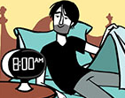
3. 
4. 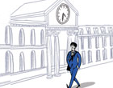
5. 
6. 
7. 
8. 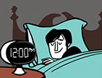
9. 
10. 
11. 
12. 

**Valeria's day: Activity 1**

1. an administrator
2. on weekdays
3. learns English

**Valeria's day: Activity 2**

**Morning**  
She gets up at 6:00 .  
She starts work at 9:00 .  
  
**Afternoon**  
She has coffee at 1:30 .  
She finishes work at 5:30 and gets home around 6:00 .  
  
**Weekends**  
Valeria and her husband don't work on the weekends.  
She usually gets up around 8:00 .  
Her husband makes breakfast for the family.  
She goes English class on Sunday at 4:00.  
She goes to bed at 10:30 at night but doesn't go to sleep until about 11:00.