***can / can't* (+/-)**

1. can speak
2. can't go
3. can't play
4. can park
5. can't come
6. can meet
7. can't take
8. can swim

***can / can't* (?)**

1. Can I close
2. Can she play
3. Can I use
4. Can you call
5. Can I open
6. Can we take
7. Can he drive
8. Can you come

**Verb phrases: Activity 1**

|  |  |  |  |
| --- | --- | --- | --- |
|  |  |  |  |
|  |  |  |  |
|  |  |  |  |

**Verb phrases: Activity 2**

1. 
2. 
3. 
4. 
5. 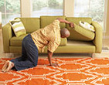
6. 
7. 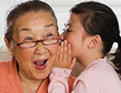
8. 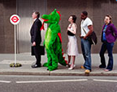
9. 
10. 
11. 

**Verb phrases: Activity 3**

|  |  |  |  |
| --- | --- | --- | --- |
| 1. | call a taxi | 5. | met a friend |
| 2. | buy a newspaper | 6. | run a race |
| 3. | hear a noise | 7. | paint a picture |
| 4. | sing a song | 8. | see a movie |

**/ʌ/, the letter *o***

1. I can't sing.
2. She can dance very well.
3. He can cook.
4. I can't come to the meeting.
5. You can't park here.
6. I can drive.

**Let's go swimming: Activity 1**

1. Two friends.
2. In the street.
3. At home.
4. A husband and wife.
5. Outside the office.

**Let's go swimming: Activity 2**

1. Saturday afternoon
2. the hospital
3. this evening
4. the address
5. can't find his keys