***be* or *do*?: Activity 1**

|  |  |
| --- | --- |
| **Are you...?** | **Do you...?** |
| * cold * bored * frightened * talking to me * using the internet * calling a taxi | * remember his name * get up early * walk to work * have lunch at home * wear glasses * like animals |

***be* or *do*?: Activity 2**

**1.  A** Does your parter cook?  
     **B** Yes. He 's making dinner now.  
**2.  A** Are you busy?  
     **B** Yes, I 'm doing my homework.  
**3.  A** How old is your father?  
     **B** He's 70, but he doesn't want to retire.  
**4.  A** Are you watching TV?   
     **B** No, we 're playing a video game.  
**5.  A** Do you speak German?  
     **B** Yes, but I don't speak it very well.  
**6.  A** Why are you crying?  
     **B** Because I 'm feeling sad.

**Music: Activity 1**

1. 
2. 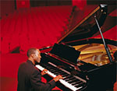
3. 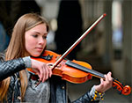
4. 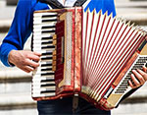
5. 
6. 
7. 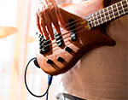
8. 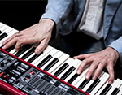
9. 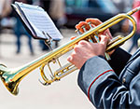

**Music: Activity 2**

1.  pianist

2.  trumpeter

3.  keyboard player

4.  violinist

5.  bass player

6.  guitarist

7.  drummer

8.  saxophonist

9.  accordionist

**/y/**

1.  you

2.  yellow

3.  music

4.  young

5.  year

6.  beautiful

**Music is changing their lives: Activity 1**

1. Venezuela
2. money
3. two

**Music is changing their lives: Activity 2**

1.  conductor

2.  project

3.  *classical music*

4.  dangerous

5.  family

6.  Los Angeles