**there is / there are**

1.  There's

2.  Are there

3.  There isn't

4.  There are

5.  Is there

6.  There aren't

7.  There's

8.  Is there

***some / any* + plural nouns**

**A** Tell me about your apartment, Danny.  
**B** Oh, OK. Um, There's a living room...  
**A** Are there any armchairs in the living room?  
**B** No, but there's an orange sofa. I'm not sure if I like it, really.  
**A** Hmm. What about the bedroom?   
**B** The bedroom is very small. There's a bed, and there are some shelves for my books. But there isn't a closet.  
**A** Oh. And the kitchen?  
**B** It isn't very big. There aren't any cupboards, but there are some nice plants.  
**A** Danny, why are you living there?  
**B** Well, it's very cheap ...

**The house - rooms**

1. a bedroom
2. a living room
3. a bathroom
4. an office
5. a hall
6. a dining room
7. a kitchen

**The house - parts of a house**

|  |  |  |  |  |
| --- | --- | --- | --- | --- |
| a balcony | a ceiling | a floor | stairs | a wall |
| C:\Users\MR.A\Desktop\pic\EF4e_01_34_01_04a.jpg | C:\Users\MR.A\Desktop\pic\EF4e_01_34_01_04b.jpg | C:\Users\MR.A\Desktop\pic\EF4e_01_34_01_04c.jpg | C:\Users\MR.A\Desktop\pic\EF4e_01_34_01_04d.jpg | C:\Users\MR.A\Desktop\pic\EF4e_01_34_01_04e.jpg |

**The house - things in a room**

1. **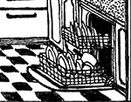**
2. **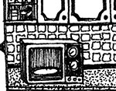**
3. **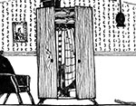**
4. **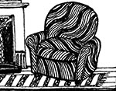**
5. **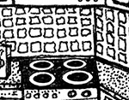**
6. ****
7. **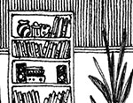**
8. **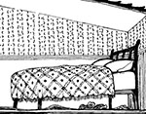**
9. **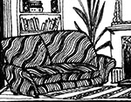**
10. **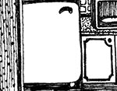**
11. **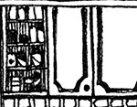**
12. **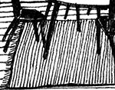**

**/ɛr/ and /ɪr/**

1. /ɛr/
2. /ɛr/
3. /ɪr/
4. /ɛr/
5. /ɪr/
6. /ɪr/
7. /ɛr/
8. /ɪr/

**This is the kitchen: Activity 1**

* kitchen
* bathroom
* living room

**This is the kitchen: Activity 2**

1. True
2. False
3. False
4. True
5. True
6. False
7. False
8. True