***there was / were*: Activity 1**

**A**  How many rooms in your hotel?  
**B** 20 rooms; 12 upstairs and 8 downstairs.  
**A** a shower in your bathroom?  
**B**  No, ; only a bathtub.  
**A** any towels?  
**B**  No, , so we asked the receptionist for towels.  
**A** a big window in your room?  
**B**  Yes, and a wonderful view of the ocean.

***there was / were*: Activity 2**

1.  There was some guests in the hotel. 

2.  We couldn't watch the news because there wasn't any TV. 

3.  Were there some cupboards in your room? 

4.  I couldn't work because there weren't a desk. 

5.  Was there restaurant in the hotel? 

6.  There weren't cups, so I couldn't make coffee.  

7.  The children were scared because there was big dog. 

8.  We couldn't park because wasn't a parking lot. 

**Prepositions – place**

1. **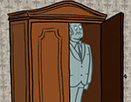**
2. **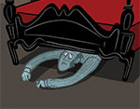**
3. **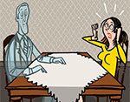**
4. **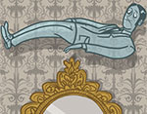**
5. **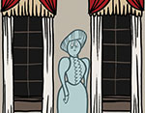**
6. **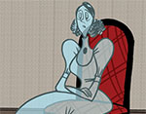**
7. **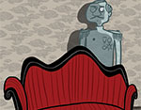**
8. **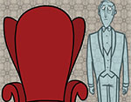**
9. **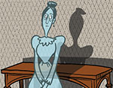**

**Prepositions - movement**

|  |  |
| --- | --- |
| **down** (the stairs) | **C:\Users\MR.A\Desktop\pic\EF4e_01_35_01_04a.jpg** |
| **into** (the wardrobe) | **C:\Users\MR.A\Desktop\pic\EF4e_01_35_01_04b.jpg** |
| **up** (the stairs) | **C:\Users\MR.A\Desktop\pic\EF4e_01_35_01_04c.jpg** |
| **from** (the bedroom) **to** (the bathroom) | **C:\Users\MR.A\Desktop\pic\EF4e_01_35_01_04d.jpg** |
| **out of** (the wardrobe) | **C:\Users\MR.A\Desktop\pic\EF4e_01_35_01_04e.jpg** |
| **through** (the window) | **C:\Users\MR.A\Desktop\pic\EF4e_01_35_01_04f.jpg** |

**A haunted house: Activity 1**

1. a small, old hotel
2. inside and outside the house
3. had strange experiences

**A haunted house: Activity 2**

1. False
2. True
3. True
4. False
5. True
6. True