**Countable / uncountable nouns**

1.  I like butter on my bread.

2.  She usually has an egg for breakfast.

3.  Do you put sugar in your coffee?

4.  Would you like some candy ?

5.  He often eats a sandwich for lunch.

6.  Do you want toast or cereal?

7.  I had an orange for dessert.

8.  We always put cheese on our pasta.

**a / an, some / any**

1. any
2. some
3. any
4. an
5. a
6. any
7. some
8. some

**Food and drink: Activity 1**

1. 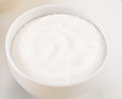
2. 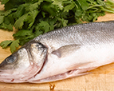
3. 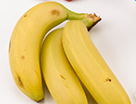
4. 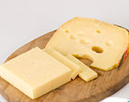
5. 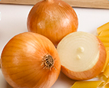
6. 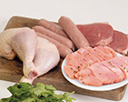
7. 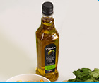
8. 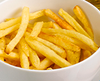
9. 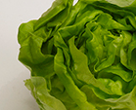
10. 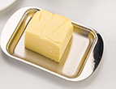
11. 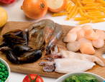
12. 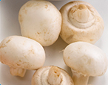

**Food and drink: Activity 2**

1. cookies
2. cereal
3. strawberries
4. coffee
5. peppers
6. fruit salad
7. spices
8. rice

**Food and drink: Activity 3**

|  |  |  |  |
| --- | --- | --- | --- |
| 1. | jam | 5. | tomatoes |
| 2. | milk | 6. | a pineapple |
| 3. | eggs | 7. | a sandwich |
| 4. | potatoes | 8. | chocolate |

**The letters *ea***

1. /ɛ/
2. /ɛ/
3. /i/
4. /ɛ/
5. /i/
6. /i/
7. /i/
8. /eɪ/
9. /i/

**My Favorite Meal: Activity 1**

1. beef
2. chicken
3. French fries
4. vegetables

**Interview with a Detective: Activity 2**

Speaker 1 D  
Speaker 2 C  
Speaker 3 A  
Speaker 4 B