**Quantifiers: Activity 1**

1. How much
2. How much
3. How many
4. How much
5. How many
6. How many
7. How much
8. How many

**Quantifiers: Activity 2**

**1.**  I don't put much salt on my food.  
**2.**  **A** How much chocolate do you eat?   
     **B** A little .  
**3.**  We don't eat lots of candy.  
**4.**  **A** How much fruit do you buy?  
     **B** A lot.  
**5.**  We eat a lot of fish.   
**6.**  **A** Do your children drink milk?  
     **B** No. Not much .  
**7.**  Donna ate her hamburger, but she didn't eat many French fries.  
**8.**  **A** How many vegetables do you eat?  
     **B** None . I don't like them.  
**9.**  I had a few cookies with my coffee.  
**10. A** Do you eat much meat?  
      **B** No, I don't eat any meat. I'm a vegetarian.

**Food containers: Activity 1**

1. 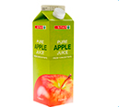
2. 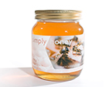
3. 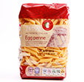
4. 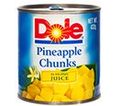
5. 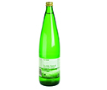
6. 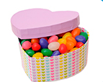
7. 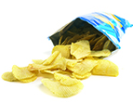

**Food containers: Activity 2**

1. jar
2. package
3. can
4. bottle
5. box
6. carton
7. can

**/ʃ/ and /s/**

1. /ʃ/
2. /s/
3. /s/
4. /ʃ/
5. /ʃ/
6. /s/
7. /ʃ/
8. /s/

**Healthy eating: Activity 1**

1. an expert on food
2. five
3. unhealthy

**Healthy eating: Activity 2**

1. food
2. rice
3. fruit
4. eggs
5. cheese
6. week