Grammar test
﻿﻿﻿Choose the correct options to complete the sentences.
1. "_______ you at work?" "No, I'm sitting in a coffee shop."
  - Is
  - Are
  - Do
2. Call _______ when your bus arrives. We can pick you up at the station.
  - our
  - us
  - we
3. "______ in malls?" "'No, I like the small stores downtown."
  - Are you like shopping
  - Do you like shopping
  - Do you like shop
4. Keiko _______ like baseball. She thinks it's boring.
  - doesn't
  - don't
  - isn't
5. Eun hates _______ for buses.
  - wait
  - waits
  - waiting
6. "Do you like musicals?" "Yes, I love _______."
  - it
  - they
  - them
7. My grandfather _______ at night. He can't see very well.
  - doesn't like drive
  - doesn't driving
  - doesn't like driving
8. "Why _______ you doing your homework?" "Because I don't have homework today - it's the weekend!"
  - aren't
  - isn't
  - don't
9. If Aiko gets to work early, we can ask _______ to meet for coffee this morning.
  - her
  - she
  - us
10. Pedro _______ drink coffee. He likes drinking tea.
  - don't
  - doesn't
  - isn't
11. Dara loves _______ history.
  - study
  - studying
  - studies
12. I'm listening to the new Beyoncé song, and I love _______!
  - it
  - them
  - him

Vocabulary test
Choose the correct options to complete the sentences.
1. I'm ______– it never rains in August, but today it's raining!
- strange
- comfortable
- surprised
2. The meeting is on Tuesday, the ______ of January.
- 5th
- 5st
- 5rd
3. Carmen's brother is a famous ______.
- pianist
- accordion
- keyboard
4. You can visit the ______ when the Queen isn't living there.
- mountain
- palace
- village
5. My birthday is on the ______ of September.
- twelve
- twenty-two
- twenty-second
6. She plays the ______ in a jazz band.
- violinist
- saxophonist
- trumpet
7. He came ______ the room and sat down.
- inside
- through
- into
8. ______ is a holiday in a lot of countries.
- January 1st
- 1st of January
- 1 of January
9. Meg wants to learn to play the ______.
- trumpeter
- guitarist
- drums
10. I ______ home for work at about 7:00.
- leave
- decide
- arrive
11. I arrive in Cusco on June ______.
- nine
- nineteen
- ninth
12. My uncle is a ______ player.
- violinist
- bass
- drummer

Dictation
Listen and write the words you hear. Use contractions. Write the numbers as words.

- ______ ______ ______ ______ ______ ______ ______ ______ ______ ______ ______ .
- ______ ______ ______ ______ ______ ______ ______ .
- ______ ______ ______ ______ ______ ______ ______ ______ ______ .
- ______ ______ ______ ______ ______ ______ ______ ______ .
- ______ ______ ______ ______ ______ .
- ______ ______ ______ ______ ______ ______ ______ ______ ______ ______ ______ .

Challenge
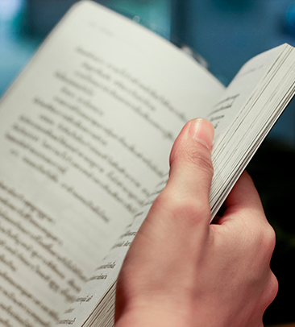 | Think of your favorite story. Write a paragraph to share in class that summarizes the story. Think about:  - the characters  - the setting  - why you like it  Go to Discussions and share your ideas with your classmates.

