Grammar test
﻿﻿﻿Choose the correct options to complete the sentences.
1. We didn't like the house we rented for our skiing vacation because ______ a fireplace.
- there isn't
- there wasn't
- there weren't
2. ______ about 1,500 types of birds in the Amazon rainforest.
- There's
- There are
- They are
3. Mark ______ at work yesterday.
- isn't
- didn't be
- wasn't
4. "What time ______ home last night?" "Not until after 4 a.m.!"
- you did get
- did you get
- you got
5. ______ over two million visitors to the Taj Mahal last year.
- There were
- There was
- They were
6. "How many rooms ______ in the White House?" "132 - it's very big!"
- are they
- there are
- are there
7. Lina ______ to class yesterday.
- didn't come
- didn't came
- don't come
8. There are ______ new videos on our website today. Have a look!
- a
- some
- any
9. I ______ to the restaurant and parked outside.
- drove
- drives
- drive
10. ______ a problem with Facebook yesterday? I couldn't upload my photos.
- Was there
- Were there
- Was it
11. There aren't ______ plants in my bedroom.
- a
- any
- some
12. ______ a phone on the table. Whose is it?
- It's
- There's
- There are

Vocabulary test
Choose the correct options to complete the sentences.
1. Diane says she ______ a ghost last night.
  - saw
  - said
  - sat
2. There are some cold drinks in the ______ .
  - cupboard
  - refrigerator
  - shelf
3. Do you want to take the elevator or walk ______ the stairs?
  - in
  - over
  - up
4. Zainab needs to rent an apartment with a ______ for her new car.
  - garage
  - floor
  - balcony
5. When Clare was in LA, she saw a famous singer coming ______ a hotel.
  - out of
  - from
  - down
6. I'm quite nervous about today's exam. I ______ up at 5:00 a.m.
  - waked
  - woke
  - wake
7. Lili ______ $20 on the street yesterday.
  - felt
  - fell
  - found
8. We walked from the railway station ______ the downtown area.
  - to
  - out
  - over
9. Karl's house has a very small ______ where he has his desk and his computer.
  - yard
  - bathroom
  - office
10. My glasses fell on the ______ and broke.
  - floor
  - wall
  - ceiling
11. You can't see Nicola in the photo - she's ______ Stuart.
  - between
  - behind
  - in front of
12. My uncle ______ me to ride a bike.
  - thought
  - took
  - taught

Dictation
Listen and write the words you hear. Use contractions.
- ______ ______ ______ ______ ______ ______ ______ ______ ______ ______ .
- ______ ______ ______ ______ , ______ ______ ______ ______ ______.
- ______ ______ ______ , ______ ______ ______ ______ ______ ______ ______ ______ ______.
- ______ ______ ______ ______ , ______ ______ ______ ______ ______ ______.
- ______ ______ ______ ______ ______ .
- ______ ______ ______ ______ .
Challenge
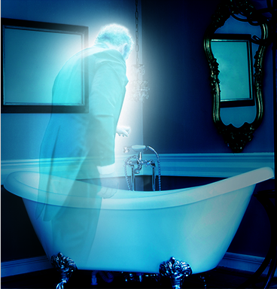 | Go online to research a famous haunted place or building in your country. Write a paragraph to share in class about the place or building. Think about:  - where is the building / place?  - how old is it?  - what are some of the stories about it being haunted?  Go to Discussions and share your information with your classmates.

