Vocabulary: in a hotel
Listen and read. Match the pictures to the correct hotel words.
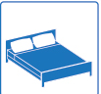 | 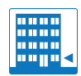 | 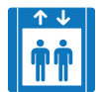 | 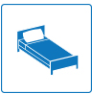 | 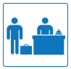

Interactive Video: you hear / you say
Watch the video of Jenny checking in. Try to remember what she says. You can read the video script to help you. Then record Jenny's part of the conversation.

Receptionist: Good evening, madam.
Jenny: Hello. I have a reservation. My name’s Jennifer Zielinski.
Receptionist: Can you spell that, please?
Jenny: Z-I-E-L-I-N-S-K-I.
Receptionist: For five nights?
Jenny: Yes, that’s right.
Receptionist: Can I have your passport, please?
Jenny: Just a second… Here you are.
Receptionist: Thank you. Can you sign here, please? Thank you. Here’s your key. It’s room 306, on the third floor. The lift is over there.
Jenny: The lift? Oh, the elevator.
Receptionist: Yes. Enjoy your stay, Ms. Zielinski.
Jenny: Thank you.

Interactive Video: social English phrases
Watch the Social English phrases. Then record yourself saying them.
Jenny: I’m here on business.
Jenny: I’m from New York. What about you?
Waitress: No problem.
Rob: This is Rob. Rob Walker.
Jenny: That’s perfect.
Jenny: It’s time for bed.

