Vocabulary: Telling the time
Listen and read. Match the time phrase to the correct clock.
1. It's ten after six.
- 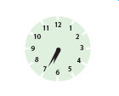
- 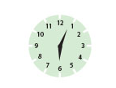
- 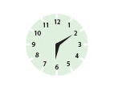
2. It's half past six.
- 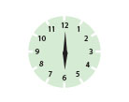
- 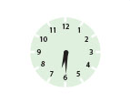
- 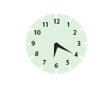
3. It's (a) quarter after six.
- 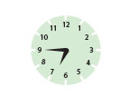
- 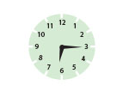
4. It's five to seven.
- 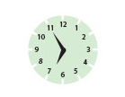
5. It's three minutes after six.
6. It's six o'clock.
7. It's twenty-five to seven.
8. It's twenty after six.
9. It's (a) quarter to seven.

Interactive Video: you hear / you say
Watch the video of Rob and Jenny buying a coffee. Try to remember what Rob says. You can read the video script to help you. Then record Rob's part of the conversation.

Barista: Can I help you?
Rob: What would you like, Jenny?
Jenny: An espresso, please.
Barista: Single or double?
Jenny: Double.
Rob: Can I have a latte, please?
Barista: Regular or large?
Rob: Large.
Barista: To have here or take away?
Rob: To take away.
Barista: Anything else?
Jenny: No, thanks.
Rob: A brownie for me, please... and a croissant.
Barista: OK.
Rob: How much is that?
Barista: That's £12.45, please.
Rob: Sorry, how much?
Barista: £12.45. Thank you. And your change.
Rob: Thanks.

Interactive Video: social English phrases
Watch the Social English phrases. Then record yourself saying them.
Rob: Here we are.
Karen: Is this your first time in the UK?
Daniel: Would you like something to drink?
Daniel: Talk to you later.

