**Vocabulary: clothes**

Listen to the words in the box. Match the words to the correct pictures.

|  |
| --- |
| a T-shirt a shirt a jacket pants a sweater shoes a skirt jeans |

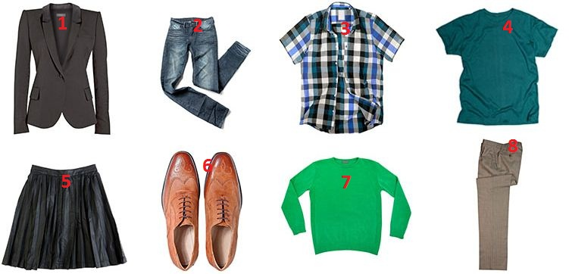

|  |  |  |  |
| --- | --- | --- | --- |
| 1. |  | 5. |  |
| 2. |  | 6. |  |
| 3. |  | 7. |  |
| 4. |  | 8. |  |

**Interactive Video: you hear / you say**

Watch the video of Rob buying clothes. Try to remember what he says. You can read the video script to help you. Then record Rob's part of the conversation.

|  |  |
| --- | --- |
| **Assistant:** Can I help you?  **Rob:** Yes, what size is this shirt?  **Assistant:** Let’s see. It’s a small. What size do you need?  **Rob:** A medium.  **Assistant:** This is a medium.  **Rob:** Thanks. Where can I try it on?  **Assistant:** The changing rooms are over there.  **Rob:** Thank you.  **Assistant:** How is it?  **Rob:** It’s fine. How much is it?  **Assistant:** It’s £44.99. |  |

**Interactive Video: social English phrases**

Watch the Social English phrases. Then record yourself saying them.

|  |  |
| --- | --- |
| **Jenny:** It’s so cool!  **Jenny:** Right now?  **Eddie:** Wait a minute.  **Jenny:** I have to go.  **Eddie:** Have fun!  **Rob:** What’s wrong?  **Jenny:** No way! |  |