Vocabulary: directions
Listen to the words in the box. Match the words to the correct pictures.
1. ﻿across from
- 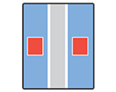
- 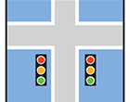
- 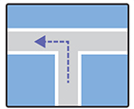
2. go straight ahead
- 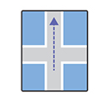
- 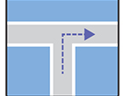
- 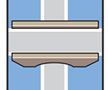
3. on the corner
- 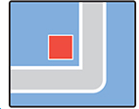
- 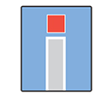
4. turn left
5. go past the church
- 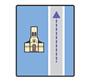
6. at the traffic lights
7. turn right
8. at the end of the street
9. a bridge

Interactive Video: you hear / you say
Watch the video of Jenny asking for directions. Try to remember what she says. You can read the video script to help you. Then record Jenny's part of the conversation.
Jenny: Excuse me, please. Where’s the Tate Modern?
Man: Sorry, I don’t live here.
Jenny: Excuse me. Is the Tate Modern near here?
Boy: The Tate Modern? It’s near here, but I don’t know exactly where. Sorry.
Jenny: Thank you.
Jenny: Excuse me. Can you tell me the way to the Tate Modern, please?
Woman: Yes, of course. Go straight on. Go past the church, then turn left at the traffic lights. And it’s at the end of the street.
Jenny: Sorry, could you say that again, please?
Woman: Yes, go straight on. Go past the church, then turn left at the
traffic lights. And it’s at the end of the street. You can’t miss it!
Jenny: Thank you.

Interactive Video: social English phrases
Watch the Social English phrases. Then record yourself saying them.
Jenny: What a view!
Rob: What would you like to visit?
Jenny: What is there to see?
Rob: We could go to the Globe Theatre.
Daniel: Would you like to meet for lunch?
Jenny: That’s really nice of you.
Daniel: Maybe another time?
Rob: Yes, of course.

