Present continuous: Activity 1
Read Grammar Bank 1C. Then write sentences with the present continuous. Use contractions where you can. Listen and check.
Grammar Bank
1C present continuous: be + verb + -ing
EXAMPLES
1 A What are you doing?
B I'm sending a message to Sarah.
2 My brother is taking a two-month vacation in the US.
3 In this picture the woman is standing near a table.
FORM
- We use the present continuous:
1 for things happening now, at this moment.
2 for temporary things that are happening around now, this week, etc.
3 to describe what's happening in a picture.
[+]
I’m working
you / we / they ’re working
he / she / it ’s working
[–]
I’m not working
you / we / they aren’t working
he / she / it isn’t working
[?] [✓] [✗]
Are you working? Yes, I am. / No, I’m not.
Is he working? Yes, he is. / No, he isn’t.
SPELLING RULES
cook → cooking, study → studying add -ing
live → living cut the final e and add -ing
run → running if verb finishes in consonant-vowel-consonant, double the final consonant and add -ing.

1. it / not snow
___________________________ .
2. Oliver / wear a suit today
___________________________ .
3. what book / read
___________________________ ?
4. I / plan a trip to the US
___________________________ .
5. you / standing on my foot
___________________________ .
6. they / not getting along very well at the moment
___________________________ .
7. she / wear makeup
___________________________ ?
8. I / not sitting in my usual place today
___________________________ .

Present continuous: Activity 2
Read Grammar Bank 1C. Then choose the correct answers. Listen and check.
Grammar Bank
1C present continuous: be + verb + -ing
EXAMPLES
1 A What are you doing?
B I'm sending a message to Sarah.
2 My brother is taking a two-month vacation in the US.
3 In this picture the woman is standing near a table.
FORM
- We use the present continuous:
1 for things happening now, at this moment.
2 for temporary things that are happening around now, this week, etc.
3 to describe what's happening in a picture.
[+]
I’m working
you / we / they ’re working
he / she / it ’s working
[–]
I’m not working
you / we / they aren’t working
he / she / it isn’t working
[?] [✓] [✗]
Are you working? Yes, I am. / No, I’m not.
Is he working? Yes, he is. / No, he isn’t.
SPELLING RULES
cook → cooking, study → studying add -ing
live → living cut the final e and add -ing
run → running if verb finishes in consonant-vowel-consonant, double the final consonant and add -ing.
1. My dog isn't dangerous. He isn't biting / doesn't bite .
2. Why do you wear / are you wearing sunglasses? It 's raining / rains!
3. You can turn off the radio. I don't listen / 'm not listening to it.
4. I 'm needing / need to find an ATM.
5. A Do you usually cook / Are you usually cooking on the weekends?
B No, we normally eat / 're normally eating out.
6. Mario lives / is living in Cancun, but he works / 's working in Mexico City at the moment.
7. I usually drink tea, but I want / 'm wanting coffee today.
8. A What do you do / are you doing here?
B I 'm waiting / wait for Emma. She's late, as usual.

Clothes: Activity 1
Listen and read. Match the sentences to the correct picture.
1. blouse
- 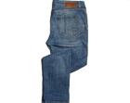
- 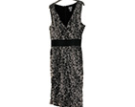
- 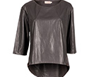
2. cardigan
- 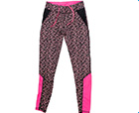
- 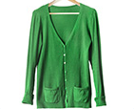
- 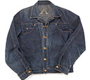
3. coat
- 
- 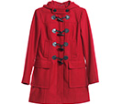
4. dress
- 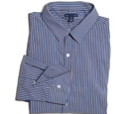
5. jacket
- 
6. jeans
- 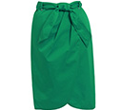
7. leggings
- 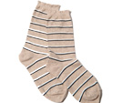
8. pajamas
9. shirt
10. shorts
11. skirt
12. socks

Clothes: Activity 2
Match the words to the correct pictures.
tracksuit ﻿pants T-shirt underwear boots flip flops sandals shoes

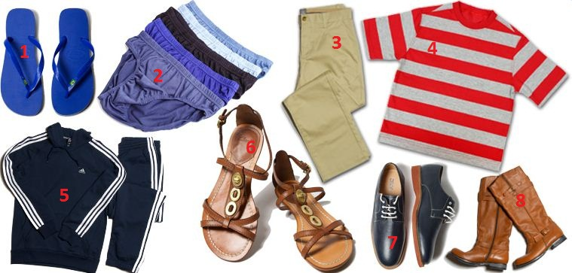

1. |  | 5.
2. |  | 6.
3. |  | 7.
4. |  | 8.

Clothes: Activity 3
Match the pictures to the correct words. Then listen and check.
1.  - tie  - hat  - top | 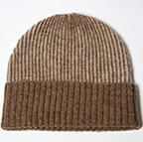
2.  - tights  - gloves  - earrings | 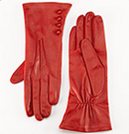
3.  - scarf  - belt  - ring | 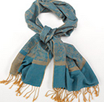
4.  - tie  - necklace  - suit | 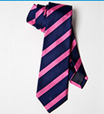
5.  - scarf  - bracelet  - cap | 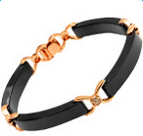
6.  - sneak﻿ers  - earrings  - gloves | 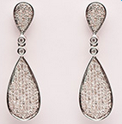
7.  - necklace  - sweater  - hat | 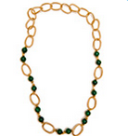
8.  - coat  - ring  - bracelet | 

Prepositions of place
Look at the picture and choose the correct answers. Then listen and check.
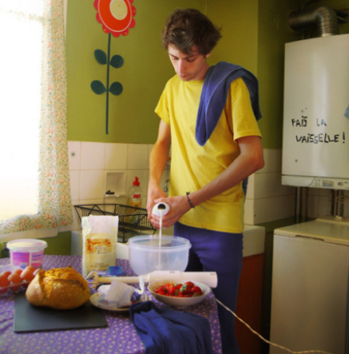
- The young man is ______ the kitchen.
  - on
  - in
  - under
- There's a table ______ him.
  - between
  - in front of
  - behind
- ______ the table there are some eggs, some bread, and some strawberries.
  - On
  - Under
  - In
- The bread is in the middle of the table. It's ______ the eggs and the strawberries.
  - between
  - above
  - behind
- There's a board ______ the bread.
  - in
  - on
  - under
- ______ the man, there's an old washing machine.
  - On the left of
  - Behind
  - In front of
- There's a window ______ the photo.
  - in the middle of
  - next to
  - on the left of
- ______ of the room, there's a sink and some cleaning products.
  - In the corner
  - In the middle
  - Next to
- There's a flower on the wall ______ the sink.
  - between
  - above
  - behind
- The sink is ______ the window.
  - in the corner of
  - next to
  - in front of

/ə/ and /ər/
Listen and read. Match the word to the correct sound. Then listen and repeat.
1. painter
  - /ə/
  - /ər/

2. her
  - /ə/
  - /ər/

3. first
  - /ə/
  - /ər/

4. photograph
  - /ə/
  - /ər/

5. picture
  - /ə/
  - /ər/

6. prefer
  - /ə/
  - /ər/

7. curly
  - /ə/
  - /ər/

8. attractive
  - /ə/
  - /ər/

9. occasion
  - /ə/
  - /ər/

10. work
  - /ə/
  - /ər/

11. university
  - /ə/
  - /ər/

Flower power: Activity 1
Listen to an advert and choose the correct answers.

- The speaker is advertising ______.
- a trip to Paris
- a new mobile phone
- an art exhibition
- She talks about a man who ______.
- takes photos of flowers
- grows flowers in his garden
- makes pictures of flowers
- The man's name is ______.
- Yves Saint Laurent
- David Hockney
- Pierre Bergé

Flower power: Activity 2
Listen to the advertisement again. Complete the sentences with a word or a number.
1. The David Hockney exhibition is in ___________ .
2. The exhibition is called Fresh ___________ .
3. Hockney has a beautiful view from his ___________ window.
4. The first picture he painted with his phone was a ___________ .
5. The Hockney exhibition finishes on ___________ 30th.
6. The exhibition costs €___________ .

