Past continuous: Activity 1
Read Grammar Bank 2B. Then complete the sentences with the correct past continuous form of the verbs. Use contractions where you can. Listen and check.
Grammar Bank
2B past continuous: was / were + verb + -ing
EXAMPLES
At 8:45 last Saturday I was walking in the park.
The birds were singing.
It wasn't raining.
A Was it raining when you got up? B No, it wasn't.
A What were you doing at 11 o'clock last night? B I was watching TV.
FORM
[+]
I / He / She / It was working.
You / We / They were working.
[–]
I / He / She / It wasn’t working.
You / We / They weren’t working.
[?] [✓] [✗]
Was he working? Yes, he was. / No, he wasn’t.
Were they working? Yes, they were. / No, they weren’t.
- We use the past continuous to describe an action in progress at a specific time in the past.
- We often use the past continuous to describe the situation at the beginning of a story, e.g., In 1972 I was living in London.

1. I took this photo when ______________ in Thailand. (we / travel)
2. He met his wife when ______________ in Japan. (he / live)
3. ______________ a coat when she went out? (she / wear)
4. ______________ when I went to work. (the sun / shine)
5. What ______________ at 7:30 last night? (you / do)
6. ______________ when you gave the instructions. (I / not listen)
7. ______________ TV when I arrived. (they / not watch)
8. It started to rain when ______________ in the park. (we / run)

Past continuous: Activity 2
Read Grammar Bank 2B. Then choose a simple past and a past continuous form to complete each sentence. Listen and check.
Grammar Bank
2B simple past or past continuous?
EXAMPLES
We were walking in the gardens when he took a photo of us.
My sister arrived when I was having lunch.
FORM
- We often use the past continuous and the simple past together in the same sentence. We use the past continuous to talk about a longer action that was happening in the background when the shorter simple past action happened.

1. She was arriving / arrived when we had / were having dinner.
2. I was breaking / broke my arm when I played / was playing volleyball.
3. Were you driving / Did you drive fast when the police were stopping / stopped you?
4. It snowed / was snowing when we were leaving / left the restaurant.
5. I wasn't seeing / didn't see the game because I was working / worked.
6. When you were calling / called me, I was talking / talked to my boss.
7. We studied / were studying English in the US when we were meeting / met .
8. Were they living / Did they live in Cairo when they were having / had their first baby?

Time and place: Activity 1
Match the words to the correct prepositions. Then listen and check.
a park the roof a store a train the airport
Lima a castle a yard a bus stop a shelf
a ship a plane the station home the balcony
the wall the kitchen Peru work school

IN | ON | AT

Time and place: Activity 2
Complete the phrases with at, in or on. Then listen and check.
1. _________ June
2. _________ March 1st
3. _________ two-thirty
4. _________ Valentine's Day
5. _________ Saturday
6. _________ the evening
7. _________ night
8. _________ New Year's Day
9. _________ winter
10. _________ 2020
Weak forms: was, were
Listen and write the words you hear.
1. _________ _________ my first semester in college.
2. I _________ _________ with him on spring break.
3. We _________ _________ a music class.
4. _________ _________ at school together.
5. She took this when we _________ _________ the Colosseum.
6. Roz and I _________ _________ with Mom and David.

Family photos: Activity 1
Listen to a conversation between Matt and Jenny about a photo. Choose the correct answers.
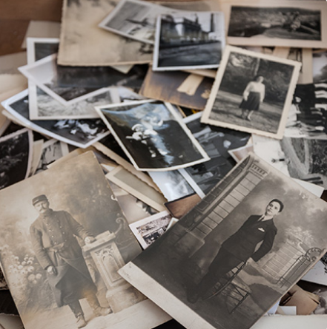
- The photo shows Matt's ______.
  - parents
  - grandparents
  - aunt and uncle
- The people in the photo are ______.
  - enjoying their free time
  - relaxing at home
  - working in a shop
- Jenny ______ the photo.
  - likes
  - doesn't like
  - doesn't mind

Family photos: Activity 2
Listen to the conversation again. Choose the correct answers.
1. The photo shows Matt's grandparents after / before / during their wedding.
2. The photo was taken in the fall / the summer / the spring .
3. The man wanted to win some money / some food / some jewelery .
4. The other people in the photo were the man's coworkers / neighbors / friends .
5. The man on the stall didn't like the photo / wanted more money for the photo / took the photo.

Writing 2: Describing a photo
Write a description of an old photo.
Make notes to answer the questions below. Add more information to make the description interesting.  - Who or what is in the photo?  - Who took it? When? Where?  - What was happening when you took the photo?  - Why do you like it?  - Where do you keep it?  Write five paragraphs. | Write here …

