Defining relative clauses: Activity 1
Read Grammar Bank 3C. Then choose the correct answers. Listen and check.
Grammar Bank
3C defining relative clauses with who, which, where
EXAMPLES
1 That's the woman who won the lottery last year.
A chef is a person who cooks food in a restaurant.
2 A clock is something that tells the time.
Is that the book that won an important prize?
3 A post office is a place where you can buy stamps.
That's the restaurant where I had dinner last week.
FORM
- We use defining relative clauses to explain what a person, thing or place is or does.
1 Use who for a person.
2 Use that for a thing.
3 Use where for a place.
- The verb after where needs a subject, e.g., you.
- We can also use that to talk about a place, e.g.,
A post office is a place that sells stamps.

1. A mail carrier is the person who / where / which brings you your packages and letters.
2. An octopus is an animal that / who / where lives in the ocean and has eight legs.
3. A lawnmower is a machine that / who / where cuts the grass.
4. A surgeon is a doctor which / where / who does operations.
5. A changing room is a room which / where / who people try on clothes.
6. A porter is the person which / where / who helps you with your luggage.
7. A garage is a place which / where / who mechanics repair cars.
8. Garlic is a vegetable that / who / where has a strong smell.

Defining relative clauses: Activity 2
Read Grammar Bank 3C. Then write sentences with who, that or where. Use contractions where you can. Listen and check.
Grammar Bank
3C defining relative clauses with who, which, where
EXAMPLES
1 That's the woman who won the lottery last year.
A chef is a person who cooks food in a restaurant.
2 A clock is something that tells the time.
Is that the book that won an important prize?
3 A post office is a place where you can buy stamps.
That's the restaurant where I had dinner last week.
FORM
- We use defining relative clauses to explain what a person, thing or place is or does.
1 Use who for a person.
2 Use that for a thing.
3 Use where for a place.
- The verb after where needs a subject, e.g., you.
- We can also use that to talk about a place, e.g.,
A post office is a place that sells stamps.

1. She / the woman / catches the same bus as me
_______________________________ .
2. This / the light / is broken
_______________________________ .
3. They / the children / live next door to me
_______________________________ .
4. This / the restaurant / they make great pizza
_______________________________ .
5. That / the room / we have our meetings
_______________________________ .
6. He / the teacher / teaches my sister
_______________________________ .
7. That / the switch / controls the air conditioning
_______________________________ .
8. That / the store / I bought my wedding dress
_______________________________ .

Paraphrasing: Activity 1
Match 1–8 to a–h to make definitions. Then listen and check.
1. It's somebody ___
2. It's something ___
3. It's somehere ___
4. It's a kind of ___
5. It's the opposite ___
6. It's like ___
7. It's similar ___
8. It's a verb. For example, ___
a to a wallet, but it's for a woman.
b who shows you around a city or a museum.
c a sweater, but it has buttons.
d you do this to the TV when you've finished watching something.
e where people go when they want to send a package or a letter.
f that we use to pay, instead of cash.
g of expensive.
h fruit. It's long and yellow.

Paraphrasing: Activity 2
Complete the definitions with the words in the box. Then listen and check.
like something similar example opposite
kind somewhere somebody
1. It's the __________ of generous. CHEAP
2. They're __________ to sandals, but they're for the swimming pool. FLIP-FLOPS
3. It's __________ who designs buildings. ARCHITECT
4. It's a verb. For __________ , you do this when you want to use a bike for an hour. RENT
5. It's a __________ of hat that protects your face from the sun. CAP
6. It's __________ a house, but it's smaller and you usualy rent it. APARTMENT
7. It's __________ where you go to see a play. THEATER
8. It's __________ that we buy when we're on vacation. SOUVENIR

Silent e
Listen and write the words you hear. Then listen and repeat.
- ___________
- ___________
- ___________
- ___________
- ___________
- ___________

Word games: Activity 1
Listen to a radio program about the word game Scrabble. Choose the correct answers.
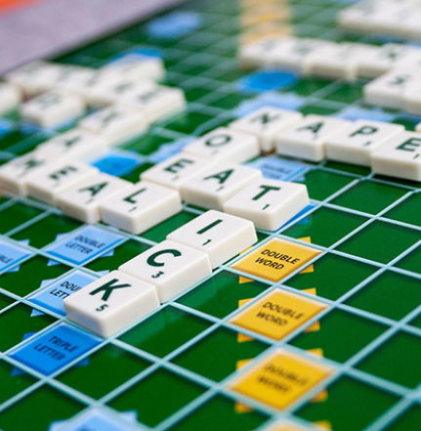

- Scrabble was invented in ______.
  - Australia
  - the UK
  - the US
- Scrabble has had ______ different names.
  - two
  - four
  - three
- Scrabble has the same ______ as the first version of the game.
  - board
  - tiles
  - rules

Word games: Activity 2
Listen to the radio program again. Read the sentences and write T (true) or F (false).
1. Alfred Mosher Butts was out of work when he invented the game. ___
2. The game of Lexico had a board and letter tiles. ___
3. Butts used a newspaper to count the frequency of the letters in English. ___
4. Butts gave the letters A, E, I, O and U one point each. ___
5. Butt gave 12 points to the most difficult letters to use. ___
6. Scrabble became popular in 1948. ___
7. Butts and Brunot sold the rights to the game to another manufacturer. ___
8. You can buy Scrabble in more than two hundred different countries. ___

