Superlatives: Activity 1
Read Grammar Bank 5B. Then complete the sentences with a superlative. Listen and check.
Grammar Bank
5B superlatives
EXAMPLES
1 Tokyo is the cleanest city in the world.
Spain is one of the most popular vacation destinations.
Camping is the least expensive way to go on vacation.
2 It's the most beautiful city I've ever been to.
It's the best movie I've seen this year.
FORM
1 We use the + superlative adjectives to say which is the biggest, etc. in a group.
- After superlatives we use in + names of places or singular words for groups of people, e.g.,
It's the noisiest city in the world. Ann's the oldest in the class.
- We can also use the least + adjective, e.g., the least expensive OR the cheapest.
2 We often use the + superlative with the present perfect + ever.
SPELLING RULES
- one-syllable adjectives: + -est or -st, e.g., the coldest
- adjectives ending in one vowel + one consonant: double consonant + -est, e.g., the thinnest.
- one- or two-syllable adjectives ending in consonant + y: change y to i + -est, e.g., the healthiest.
- one-syllable adjectives ending in -ed: the most + adjective, e.g., the most tired,
- two- or more-syllable adjectives: the most + adjective, e.g., the most beautiful.
- irregular: good → the best; bad → the worst; far → the farthest ﻿(the furthest).

1. Is Shanghai _________ city in the world? (big)
2. They are _________ people I know. (generous)
3. Early morning is _________ time to drive downtown. (bad)
4. She's _________ girl in school. (friendly)
5. _________ I've ever flown is to Brazil. (far)
6. Yesterday was _________ day of the year. (hot)
7. _________ time to visit New England is in fall. (good)
8. This is _________ part of the exam. (important)

Superlatives: Activity 2
Read Grammar Bank 5B. Then write sentences with a superlative + ever + the present perfect. Use contractions. Listen and check.
Grammar Bank
5B superlatives
EXAMPLES
1 Tokyo is the cleanest city in the world.
Spain is one of the most popular vacation destinations.
Camping is the least expensive way to go on vacation.
2 It's the most beautiful city I've ever been to.
It's the best movie I've seen this year.
FORM
1 We use the + superlative adjectives to say which is the biggest, etc. in a group.
- After superlatives we use in + names of places or singular words for groups of people, e.g.,
It's the noisiest city in the world. Ann's the oldest in the class.
- We can also use the least + adjective, e.g., the least expensive OR the cheapest.
2 We often use the + superlative with the present perfect + ever.
SPELLING RULES
- one-syllable adjectives: + -est or -st, e.g., the coldest
- adjectives ending in one vowel + one consonant: double consonant + -est, e.g., the thinnest.
- one- or two-syllable adjectives ending in consonant + y: change y to i + -est, e.g., the healthiest.
- one-syllable adjectives ending in -ed: the most + adjective, e.g., the most tired,
- two- or more-syllable adjectives: the most + adjective, e.g., the most beautiful.
- irregular: good → the best; bad → the worst; far → the farthest ﻿(the furthest).

1. It / exciting job / I / do
_______________________________ .
2. This / long book / I / read
_______________________________ .
3. It / good movie / I / see
_______________________________ .
4. He / attractive man / I / meet
_______________________________ .
5. It / hot place / I / be to
_______________________________ .
6. She / interesting teacher / I / have
_______________________________ .
7. It / easy exam / I / do
_______________________________ .
8. It / bad meal / I eat
_______________________________ .

Describing a town or city: Activity 1
Look at the map. Then read the sentences about York and choose the correct answers. Listen and check.
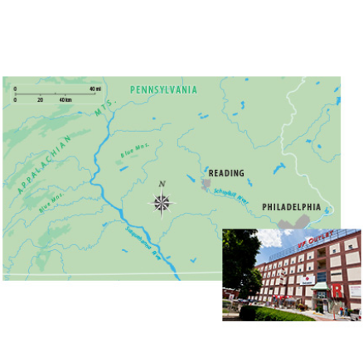
  - Reading is a city in the ______ of the state of Pennsylvania in the US.
  - east
  - west
  - It's located ______.
  - in the mountains
  - on the Schuykill River
  - It is about 60 miles ______ of Philadelphia.
  - east
  - west
  - It is a ______ city, and it has a population of about 88,000.
  - large
  - small
  - It is famous for its __________ , which were the first in the US.
  - discount outlet shopping malls
  - shoppings
  - discount

Describing a town or city: Activity 2
Match the adjectives cards to their opposites.
noisy modern boring crowded dangerous polluted

quiet |  | historic
exciting / interesting |  | safe
empty |  | clean
Describing a town or city: Activity 3
Put the words into the correct boxes. Then listen and check.

ruins statue castle harbor canal lake town hall department store hill bridge market palace museum shopping mall city walls

Places where you can buy things | Historic buildings and monuments | Others

Sentence stress
Listen and write the words you hear. Then listen and repeat. Try to copy the rhythm.
1. What's the _________ _________ city you've ever been to?
2. What's the _________ _________ vacation you've ever had?
3. What's the _________ _________ movie you've ever seen?
4. What's the _________ _________ sporting event you've ever watched?
5. What's the _________ _________ thing you've ever bought?
6. Who's the _________ _________ person you've ever met?
7. What's the _________ _________ sport you've ever played?
8. What's the _________ _________ subject you've ever studied?

Visiting Brazil: Activity 1
Listen to a radio travel program about Brazil. Check the places that are mentioned in the program.
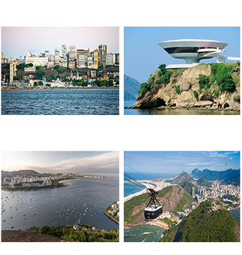
- Búzios
- Salvador
- Brasília
- Rio de Janeiro
- São Paulo
- Recife

Visiting Brazil: Activity 2
Listen again and answer T (true) or F (false).
1. Salvador is an old city. ____
2. Eight million people live in Rio de Janeiro. ____
3. The churches in Rio de Janeiro are all very new. ____
4. You can take a bus to visit the peninsula. ____
5. The best time to visit is December to March. ____

Writing 4: Describing where you live
Write a description of a place where you would like to live.
Think of a city or town where you would like to live. Make notes to answer the questions below. Add more information to make the description interesting.  - Where would you like to live? Where is it? How big is it?  - What's the place like? What is there to see there?  - What's the weather like?  - What's it famous for?  - What's the best thing about this place? Why would you like to live there?  Write five paragraphs. | Write here…

