if + past, would + base form (Second conditional): Activity 1
Read Grammar Bank 9A. Then match the sentence halves. Listen and check.
Grammar Bank
9A second conditional: if + past, would / wouldn't + base form
EXAMPLES
1 If a cow attacked me, I'd run away.
If she didn't have a dog, she wouldn't exercise.
Would you go for a swim if there were sharks in the ocean?
2 If I had more time, I'd exercise more.
I'd exercise more if I had more time.
3 If we went by car, we could stop at places on the way.
FORM
1 We use if + past to talk about an imaginary or hypothetical future situation and would / wouldn't + base form to talk about the consequence.
- would + base form is sometimes known as the conditional tense. We also use it without an if-clause to talk about imaginary or hypothetical situations, e.g., I'd never have a cat as a pet. They'd be happier in a bigger house.
- would / wouldn't = the same for all persons. Contractions: 'd = would (I'd, you'd, he'd, etc); wouldn't = would not
2 In a second conditional the if-clause can come first or second. If the if-clause comes first, we usually put a comma before the next clause.
3 We can also use could + base form instead of would + base form in the next clause.

1. You'd feel much better ___
2. I'd enjoy the weekend more ___
3. If you didn't have to study for your exams, ___
4. Would you really wear a suit ___
5. If we took a taxi, ___
6. I wouldn't work ___
7. If I went to Los Angeles, ___
A if you exercised.
B would you come to visit me?
C if I bought one for you?
D we could go out tonight.
E if I didn't have to work on Saturday.
F we would get there sooner.
G if I didn't need the money.

if + past, would + base form (Second conditional): Activity 2

Read Grammar Bank 9A. Then complete the sentences with the correct form of the verb to make second conditional sentences. Use contractions where you can. Listen and check.

Grammar Bank
9A second conditional: if + past, would / wouldn't + base form
EXAMPLES
1 If a cow attacked me, I'd run away.
If she didn't have a dog, she wouldn't exercise.
Would you go for a swim if there were sharks in the ocean?
2 If I had more time, I'd exercise more.
I'd exercise more if I had more time.
3 If we went by car, we could stop at places on the way.
FORM
1 We use if + past to talk about an imaginary or hypothetical future situation and would / wouldn't + base form to talk about the consequence.
- would + base form is sometimes known as the conditional tense. We also use it without an if-clause to talk about imaginary or hypothetical situations, e.g., I'd never have a cat as a pet. They'd be happier in a bigger house.
- would / wouldn't = the same for all persons. Contractions: 'd = would (I'd, you'd, he'd, etc); wouldn't = would not
2 In a second conditional the if-clause can come first or second. If the if-clause comes first, we usually put a comma before the next clause.
3 We can also use could + base form instead of would + base form in the next clause.

1. We _________ a dog if we _________ a yard. (get, have)
2. If you _________ Indian food, I'm sure you _________ it. (try, like)
3. I _________ it if I _________ it. (not buy, not like)
4. I _________ you to the airport tomorrow if I _________ work. (take, not have to)
5. If we _________ a car, we _________ drive to the mountains. (rent, can)
6. We _________ my parents more often if they _________ closer. (see, live)
7. I _________ to that restaurant if I _________ you – it's very expensive. (not go, be)
8. You _________ more if you _________ more homework. (learn, do)
9. I _________ to work if the traffic _________ so bad. (bike, not be)
10. I love living here. I _________ happy if I _________ leave. (not be, have to)
Animals and insects: Activity 1
Listen and read. Match the pictures to the correct words.
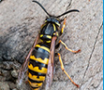 | 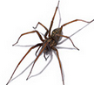 | 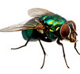
 |  | 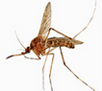

Animals and insects: Activity 2
Listen and read. Match the words to the correct pictures.
1.bat
- 
- 
- 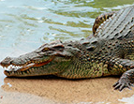
2. bear
- 
- 
- 
3.bird
- 
- 
- 
4. camel
- 
- 
5. crocodile
- 
6. deer
7. elephant
8. giraffe
9. kangaroo
10. lion
11. monkey
12. mouse

Animals and insects: Activity 3
Match the pictures to the correct words. Then listen and check.
1.  - dolphin  - rabbit  - bee | 
2.  - jellyfish  - butterfly  - rat | 
3.  - shark  - snake  - horse | 
4.  - tiger  - whale  - sheep | 
5.  - rat  - dolphin  - pig | 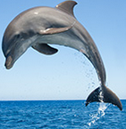
6.  - spider  - jellyfish  - snake | 
7.  - tiger  - shark  - wasp | 
8.  - whale  - bull  - rabbit | 

Word stress
Listen and choose the correct pronunciation. Then listen and repeat.
1.
- ca|mel
- ca|mel

2.
- cro|co|dile
- cro|co|dile

3.
- dol|phin
- dol|phin

4.
- e|le|phant
- e|le|phant

5.
- gi|raffe
- gi|raffe

6.
- kan|ga|roo
- kan|ga|roo

7.
- li|on﻿
- li|on

8.
- mos|qui|to
- mos|qui|to

Crocodile Attack! Activity 1
Read and listen to the article. Choose the correct answers.
Crocodile Attack!
If you were swimming at the edge of the water in Southern Florida in the US, and you saw a crocodile coming towards you, what would you do? Would you get out of the water and run away fast, make a loud noise or pretend to be dead? Or would you try to fight it?
Well, all three of these are possible, but the best thing to do depends on where the crocodile is at the time. If it comes towards you on land, experts say you should turn around and run away as fast as possible. Crocodiles can run faster than humans over a short distance, but they soon get tired. If they miss their first chance to catch their victim, they usually start looking for something else.
If you’re in the water, then splash around to make a noise so that the animal gets confused. If this doesn’t work, push your thumb or fingers into the crocodile’s eye. This is the most sensitive area of the crocodile’s body and it is the place where you can cause the animal the most pain. It will also be very surprised by your attack and it’s possible that it will decide to leave you alone. Don’t try and open the crocodile’s mouth because the muscles are so strong that this is nearly impossible.
However, if the crocodile is in a bad mood, it’s possible that it will continue fighting. Your final opportunity is to pretend to be dead. If the crocodile thinks that its victim is dead, it opens its mouth for a few seconds to move the body into its throat. This can give you your last chance to escape, but it’s a very dangerous plan.
Our final advice? It’s much better to avoid crocodiles than to do any of the things above …

- The article says that if a crocodile attacks you, ______.
  - there's only one thing you can do
  - there's nothing you can do
  - there are lots of things you can do
- According to the article, the best advice is ______.
  - to try to open the crocodile's mouth
  - not to go near crocodiles
  - to pretend to be dead

Crocodile Attack! Activity 2
Read the article again and choose the correct answers.
Crocodile Attack!
If you were swimming at the edge of the water in Southern Florida in the US, and you saw a crocodile coming towards you, what would you do? Would you get out of the water and run away fast, make a loud noise or pretend to be dead? Or would you try to fight it?
Well, all three of these are possible, but the best thing to do depends on where the crocodile is at the time. If it comes towards you on land, experts say you should turn around and run away as fast as possible. Crocodiles can run faster than humans over a short distance, but they soon get tired. If they miss their first chance to catch their victim, they usually start looking for something else.
If you’re in the water, then splash around to make a noise so that the animal gets confused. If this doesn’t work, push your thumb or fingers into the crocodile’s eye. This is the most sensitive area of the crocodile’s body and it is the place where you can cause the animal the most pain. It will also be very surprised by your attack and it’s possible that it will decide to leave you alone. Don’t try and open the crocodile’s mouth because the muscles are so strong that this is nearly impossible.
However, if the crocodile is in a bad mood, it’s possible that it will continue fighting. Your final opportunity is to pretend to be dead. If the crocodile thinks that its victim is dead, it opens its mouth for a few seconds to move the body into its throat. This can give you your last chance to escape, but it’s a very dangerous plan.
Our final advice? It’s much better to avoid crocodiles than to do any of the things above …

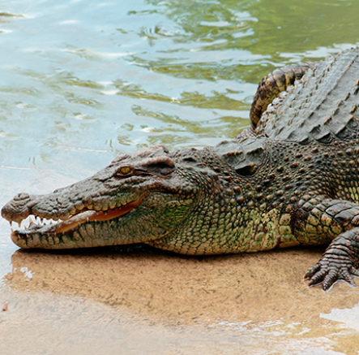
- Crocodiles aren't as fast as humans over short distances.
  - True
  - False
- Crocodiles don't usually run very far.
  - True
  - False
- If you see a crocodile coming towards you, you should wait quietly and then push your fingers into its eyes.
  - True
  - False
- Crocodiles have very strong muscles in their mouths.
  - True
  - False
- If you manage to hurt a crocodile's eyes, it always stops fighting.
  - True
  - False
- Pretending to be dead doesn't always work.
  - True
  - False

