Expressing movement: Activity 1
Read Grammar Bank 10A. Then choose the correct answers. Click on Tools for Quick tips. Listen and check.
10A expressing movement
EXAMPLES
The ball went over the goalkeeper's head and into the goal.
He drove out of the car park and along the street.
I ran over the bridge and across the park.
FORM
To express movement we use a verb of movement, e.g., go, come, run, walk, etc. and a preposition (or adverb) of movement, e.g., up, down, to, away, etc.

1. We ran to/down the ocean and jumped out of /into the water.
2. If you go past /over the bank, you'll see the supermarket on your right.
3. James walked across /along the street until he came to a big house.
4. Look! We're flying on/over the mountains now.
5. The dog started to run to / towards me, but then it suddenly stopped.
6. We biked over / out of the bridge and into / in the park.
7. In the 800 meters, the runners run around /across the track twice.
8. The cat suddenly ran around / across the road.

Expressing movement: Activity 2
Read Grammar Bank 10A. Then complete the sentences with a word from the list. Listen and check.
10A expressing movement
EXAMPLES
The ball went over the goalkeeper's head and into the goal.
He drove out of the car park and along the street.
I ran over the bridge and across the park.

FORM
To express movement we use a verb of movement, e.g., go, come, run, walk, etc. and a preposition (or adverb) of movement, e.g., up, down, away, etc.

down up over out out of in away into
1. Martin jumped _______ his car and drove away.
2. When I was walking under the bridge, a train went _______it.
3. Come _______ . The door's open.
4. This is the first floor. Go _______ the stairs - the office is on the second floor.
5. Francisco isn't here. He's gone _______ .
6. The bus stop is very close. Go _______ the building and turn left.
7. Go _______ ! I don't want to talk to you.
8. I bike _______ a big hill on my way home. I go really fast!

Sports
Put the sports in the correct box. Click on Tools for Quick tips. Then listen and check.
karate windsurfing basketball track and field baseball soccer handball rugby gymnastics yoga skiing cycling tennis volleyball

play | go | do

Expressing movement: Activity 1
Listen and read. Match the pictures to the correct words.
Quick tips
across or through?
We use across to talk about movement from one side to the other of something which has "sides", like a square, a street, or a river, e.g.,
He swam across the river.
We use through to talk about movement from one side to the other but "in something," e.g., a forest, a tunnel, a crowd, e.g.,
We walked through the crowds and reached the empty streets on the other side.

 | under the bridge |  | through the tunnel
 | along the street |  | into the store
 | around the lake |  | across the road

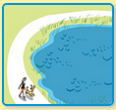 | 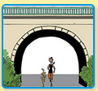 | 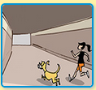
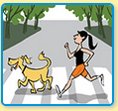 | 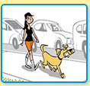 | 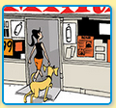

Expressing movement: Activity 2
Listen and read. Match the words to the correct pictures.
Quick tips
away and back
We use away to express movement to another place, e.g.,
Go away! I don’t want to speak to you.
The man ran away when he saw the policeman.
We use back to express movement to the place where something or somebody was before, e.g.,
After dinner we went back to our hotel.
Their dog ran away and never came back.

1. over the bridge |  | - 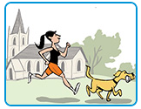  - 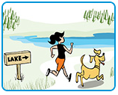  - 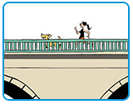
2. up the steps |  | - 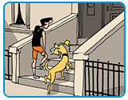  - 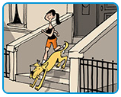
3. past the church |  | - 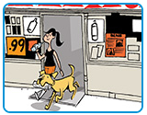
4. toward the lake |  | - 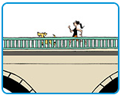
5. down the steps

6. out of the store

Word stress
Listen and read. Choose the stressed syllable. Then listen and repeat.
1. so|ccer | - first  - second
2. base|ball | - first  - second
3. bas|ket|ball | - first  - second
4. cy|cling | - first  - second
5. yo|ga | - first  - second
6. gym|nas|tics | - first  - second
7. hand|ball | - first  - second
8. ka|ra|te | - first  - second
9. rug|by | - first  - second
10. ski|ing | - first  - second
11. te|nnis | - first  - second
12. wind|sur|fing | - first  - second

Bad losers: Activity 1
Listen to five speakers talking about bad losers. Put the games or sports in the order they mention them.
card ice hocke basketball board games tennis



Bad losers: Activity 2
Listen again. Match the sentences to the speakers. You can read the audio script to help you.
Audio script
Speaker 1
The worst loser I know is my mom. We often used to play cards together when I was little, and if my mom was losing, it was safer to stop playing. She was always happy when she was winning, but when she was losing, you could see her getting angrier and angrier until she exploded. Sometimes, she used to go out of the room because she was so upset!
Speaker 2
I once had a friend who was a bad loser at tennis. In fact, we stopped talking to each other because of a tennis match. We were about twenty at the time, and on this occasion we were arguing over a point. I said the ball was out and she said it was in. In the end, she just threw her racket into the net and left. We haven’t spoken since.
Speaker 3
I have to be very careful at work when we’re talking about ice hockey. I have a colleague who gets really upset when his team loses, and he hates it if you make a joke about it. I tried it once, and he just stood up, walked out, and closed the door with a bang. He didn’t speak to me for days after that, so I don’t think I’ll try it again.
Speaker 4
My son is a very bad loser, in fact he always has been. He’s 12 now, but he still hates losing. We used to play board games together when he was little, but he always used to cry if he didn’t win. I had to choose between letting him win all the time, or making him upset if I won. In the end, I stopped playing that kind of game with him.
Speaker 5
One of the guys who plays basketball with me gets incredibly upset during games, and he spends most of the time shouting at the other players. He’s a really nervous person at the best of times, but when we’re losing, it really is too much. The referee throws him off the court at least twice a month, and once our coach told him to go home.

Speaker 1 ___________
Speaker 2 ___________
Speaker 3 ___________
Speaker 4 ___________
Speaker 5 ___________
A He / She lost a friend after playing sport with them.
B He / She is in a team with someone who's a bad loser.
C He / She has a parent who's a bad loser.
D He / She used to let one of their children win.
E He / She works with someone who's a fanatical sports fan.

Writing 7: An article
Write an article about a game you enjoy playing with your family or friends.
Make notes to answer the questions below. Add more information to make the article interesting.
- What is the game? How do you play it?
- When and why did you start playing the game? Where and when do you play it now?
- Why do you enjoy the game?
- Who would you recommend the game to? Why would you recommend it?
Write four paragraphs.

Write here …

