Word order of phrasal verbs: Activity 1
Read Grammar Bank 10B. Choose the correct answers. If both answers are possible, choose both. Listen and check.
Grammar Bank
10B word order of phrasal verbs
EXAMPLES
1 What time do you get up?
I don't usually go out during the week.
2 Put on your coat. Put your coat on. Put it on.
Turn off the TV. Turn the TV off. Turn it off.
3 I'm looking for my glasses.
A Have you found your glasses?
B No, I'm still looking for them.
FORM
- A phrasal verb = a verb + particle (preposition or adverb), e.g., get up, go out, turn off, look for.
1 Some phrasal verbs don't have an object, e.g., get up, go out.
2 Some phrasal verbs have an object and are separable. With these phrasal verbs we can put the particle (on, off, etc.) before or after the object.
- When the object is a pronoun, (me, it, him, etc.) it always goes between the verb and the particle.
Here's your coat. Put it on. NOT Put on it.
3 Some phrasal verbs have an object and are inseparable, e.g. look for. With these phrasal verbs, the verb (e.g., look) and the particle (e.g. for) are never separated.
I'm looking for my glasses. NOT I'm looking my glasses for.

- Tonight I have to ______ .
- both
- look my little sister after
- look after my little sister
- Let's _______ .
- go this evening out
- go out this evening
- both
- I'll ______ at school.
- both
- drop the children off
- drop off the children
- My brother is _______ .
- looking a new job for
- looking for a new job
- both
- You should _______ .
- throw away those old jeans
- both
- throw those old jeans away
- I don't like shopping for clothes online. I prefer to ______ before I buy them.
- try on them
- try them on
- both
- ________ before you come in.
- both
- Take off your shoes
- Take your shoes off
- We're meeting my mother tomorrow – I think you'll really .
- get along with her
- get along her with
- both
- If the jacket doesn't fit, _______ to the store.
- take back it
- take it back
- both
- What time do you ________ ?
- both
- get up in the morning
- get in the morning up

Word order of phrasal verbs: Activity 2
Read Grammar Bank 10B. Then complete the sentences with it or them and a word from the list. Listen and check.
Grammar Bank
10B word order of phrasal verbs
EXAMPLES
1 What time do you get up?
I don't usually go out during the week.
2 Put on your coat. Put your coat on. Put it on.
Turn off the TV. Turn the TV off. Turn it off.
3 I'm looking for my glasses.
A Have you found your glasses?
B No, I'm still looking for them.
FORM
- A phrasal verb = a verb + particle (preposition or adverb), e.g., get up, go out, turn off, look for.
1 Some phrasal verbs don't have an object, e.g., get up, go out.
2 Some phrasal verbs have an object and are separable. With these phrasal verbs we can put the particle (on, off, etc.) before or after the object.
- When the object is a pronoun, (me, it, him, etc.) it always goes between the verb and the particle.
Here's your coat. Put it on. NOT Put on it.
3 Some phrasal verbs have an object and are inseparable, e.g., look for. Withe these phrasal verbs, the verb (e.g. look) and the particle (e.g., for) are never separated.
I'm looking for my glasses. NOT I'm looking my glasses for.

back out on on up up

1. Your clothes are all over the floor. Pick ________ .
2. Here's your coat. Put ________.
3. A What does this word mean?
B Look ________.
4. To get your passport there are three forms. Please fill ________now.
5. You remember that money I lent you? When can you give ________ ?
6. A Is the game on TV?
B I don't know. Turn ________ and see.

Phrasal verbs: Activity 1
Listen and read. Match the pictures to the correct sentences.
Quick tips
Phrasal verbs
Wake up, get up, go out, give up, etc. are common phrasal verbs (verbs with a preposition or adverb).
Sometimes the meaning of the two separate words can help you guess the meaning of the phrasal verb, e.g., go out.
Sometimes the meaning of the two words does not help you, e.g. give up.

The game will  be over at  about 5:30. | My alarm goes off at six o'clock every morning. | We set off  for the airport  at 6:30. | I want to give up chocolate. | Don't throw away that letter! | Turn down the music! It's very loud.

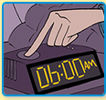 | 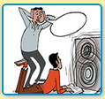 | 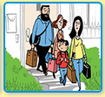
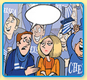 | 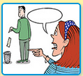 | 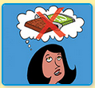

Phrasal verbs: Activity 2
Listen and read. Match the sentences to the correct pictures.
- Turn up the TV! I can't hear. |  | - 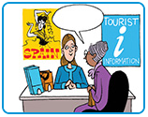  - 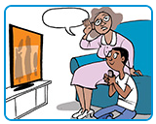  - 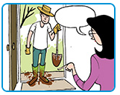
- He looked up the words in a dictionary. |  | - 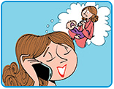  - 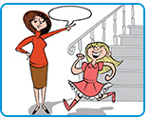  - 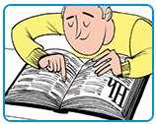
- Could you fill out this form? |  | - 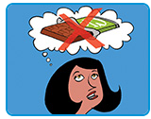  - 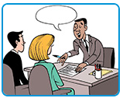  - 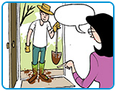
- I want to find out about hotels in Madrid.
- It's bedtime – go and put on your pajamas.
- Could you take off your boots, please? |  | - 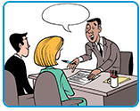
- My sister's looking after Jimmy for me today.
- I'm really looking forward to vacation. |  | - 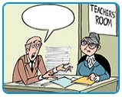

Linking
Listen and write the missing words. Then listen and repeat. Try to link the phrasal verbs and pronouns, e.g., turn_it_off.
1. I can't concentrate with the radio on. Please ______ ______ ______ .
2. There's a wet towel on the floor. ______ ______ ______.
3. If you don't know what the word means, ______ ______ ______.
4. Why have you taken your coat off? ______ ______ ______!
5. This book was very expensive. Please ______ ______ ______.
6. Why are you wearing your coat in here? ______ ______ ______!

Still tired in the morning? Activity 1
Read and listen to the article. Choose the correct headings for the tips.
Still tired in the morning?
Five tips for getting a better night's sleep.
1. ________________________________________________
Find out how much sleep you need and make sure that you get it. Go to bed and get up at the same time each day and you will have more energy than if you sleep the same number of hours at different times.
2. ________________________________________________
Your body needs natural light to produce the hormone melatonin, which regulates your sleeping and waking cycle. Don’t stay inside all day – go out on your lunch break, for example for a short walk. On a sunny day take off your sunglasses for at least half an hour to let light onto your face.
3. ________________________________________________
Take a hot bath. Then put on your pajamas and make sure your bedroom is at the right temperature. Don’t watch TV in bed, as it will stimulate rather than relax you.
4. ________________________________________________
Don’t eat big meals or drink coffee late at night. Avoid drinking before you go to bed and give up smoking! Cigarettes can cause a number of sleep problems.
5. ________________________________________________
If you wake up in the middle of the night and can’t get back to sleep, try a relaxation technique like meditation. If that doesn’t work, turn on the light and read a book. If you’re worried about something, write down your problem on a piece of paper so that you can deal with it in the morning.

1.
  - Sleep at the same times
  - Getting back to sleep
  - Create a relaxing routine before going to bed
2.
  - Avoid stimulants
  - Sleep at the same times
  - Make sure you are exposed to light during the day
3.
  - Create a relaxing routine before going to bed
  - Make sure you are exposed to light during the day
  - ﻿Getting back to sleep
4.
  - Create a relaxing routine before going to bed
  - Sleep at the same time
  - Avoid stimulants
5.
  - Avoid stimulants
  - Make sure you are exposed to light during the day
  - Getting back to sleep

Still tired in the morning? Activity 2
Read the article again. Write G (good habit) or B (bad habit).
Read
Still tired in the morning?
Five tips for getting a better night's sleep.
Sleep at the same time
Find out how much sleep you need and make sure that you get it. Go to bed and get up at the same time each day and you will have more energy than if you sleep the same number of hours at different times.
Make sure you are exposed to light during the day
Your body needs natural light to produce the hormone melatonin, which regulates your sleeping and waking cycle. Don’t stay inside all day – go out on your lunch break, for example for a short walk. On a sunny day take off your sunglasses for at least half an hour to let light onto your face.
Create a relaxing routine before going to bed
Take a hot bath. Then put on your pajamas and make sure your bedroom is at the right temperature. Don’t watch TV in bed, as it will stimulate rather than relax you.
Avoid stimulants
Don’t eat big meals or drink coffee late at night. Avoid drinking before you go to bed and give up smoking! Cigarettes can cause a number of sleep problems.
Getting back to sleep
If you wake up in the middle of the night and can’t get back to sleep, try a relaxation technique like meditation. If that doesn’t work, turn on the light and read a book. If you’re worried about something, write down your problem on a piece of paper so that you can deal with it in the morning.
1. I go to bed every night at 11 o'clock. _______
2. I sleep for six hours during the week and ten hours on the weekend. _______
3. I always have lunch at my desk to save time. _______
4. I always wear sunglasses. _______
5. My bedroom is sometimes too cold. _______
6. I sometimes watch a movie to help me get to sleep. _______
7. I usually have dinner at 7:30 p.m. _______
8. I often have a cup of coffee before I go to bed. _______
9. I keep a notebook by the side of my bed. _______
10. I sometimes meditate if I can't sleep. _______

