The passive
Read Grammar Bank 10C. Then choose the correct passive form. Listen and check.
Grammar Bank
10C the passive: be + past participle
EXAMPLES
Present: am / is / are + past participle
[+] 20 billion pieces of lego are produced every year.
[–] CDs aren't used very much nowadays.
[?] Is Spanish spoken in New Mexico?
Past: was / were + past participle
[+] The hot-air balloon was invented by two Frenchmen.
[–] Stamps weren't invented until 1840.
[?] When was the watch invented?
FORM
- We can often say things in two ways, in the active or in the passive.
Alfred Nobel invented dynamite. (active)
Dynamite was invented by Alfred Nobel. (passive)
- In the active sentence, the focus is more on Alfred Nobel.
- In the passive sentence, the focus is more on dynamite.
- We often use the passive when it isn't known or isn't important who does or did the action.
My car was stolen last week.
Volvo cars are made in Sweden.
- We use by to say who did the action.
The Lord of the Rings was written by Tolkien.

1. Many of the things we use today were invented / are invented by women.
2. These days, most children in the US are educated / were educated in public schools.
3. DNA is discovered / was discovered by Watson and Crick in 1953.
4. This morning I was woken up / am woken up by the neighbor's dog.
5. Baseball was played / is played in the spring in the US, and there are often games on TV.
6. The songs on this album were written / are written last year.
7. Millions of toys are made / were made in China every year.
8. Carols are songs which are sung / were sung in some countries at Christmas. They're usually religious.

The passive 2
Read Grammar Bank 10C. Then rewrite the sentences in the passive. Listen and check.
Grammar Bank
10C the passive: be + past participle
EXAMPLES
Present: am / is / are + past participle
[+] 20 billion pieces of lego are produced every year.
[–] CDs aren't used very much nowadays.
[?] Is Spanish spoken in New Mexico?
Past: was / were + past participle
[+] The hot-air balloon was invented by two Frenchmen.
[–] Stamps weren't invented until 1840.
[?] When was the watch invented?
FORM
- We can often say things in two ways, in the active and in the passive.
Alfred Nobel invented dynamite. (active)
Dynamite was invented by Alfred Nobel. (passive)
- In the active sentence, the focus is more on Alfred Nobel.
- In the passive sentence, the focus is more on dynamite.
- We often use the passive when it isn't known or isn't important who does or did the action.
My car was stolen last week.
Volvo cars are made in Sweden.
- We use by to say who did the action.
The Lord of the Rings was written by Tolkien.

1. Christopher Wren designed St Paul's Cathedral.
St Paul's Cathedral ________________________________ .
2. A small Italian company produces this olive oil.
This olive oil ________________________________ .
3. Shakespeare wrote Hamlet in 1603.
Hamlet ________________________________ in 1603.
4. Spielberg didn't direct the Star Wars films.
The Star Wars films ________________________________ .
5. Van Gogh painted Sunflowers in 1888.
Sunflowers ________________________________ in 1888.
6. The Chinese didn't invent glass.
Glass ________________________________ .
7. J.K. Rowling wrote the Harry Potter books.
The Harry Potter books ________________________________ .
8. They make Toyota cars in Japan.
Toyota cars ________________________________ .

People from different countries
Listen and match the countries to the words for the people of the countries, e.g. Japan, the Japanese.
- the Thais
- Belgium
- the Dutch
- the Italians
- China
- Italy
- the United States
- the Belgians
- the Chinese
- Thailand
- the Netherlands
- the Americans

People from different countries 2
Complete with the nationality adjective and the word for the people from the country, e.g., Egypt, Egyptian, the Egyptians. Listen and check.
Quick tips
Talking about people from different countries
We usually use the + nationality adjective + -s to talk about the people from a country, e.g., the Americans, the Belgians, etc.
If the nationality adjective ends with /s/, /z/, /ʃ/, or /tʃ/, we don’t add -s, e.g., the English, the Chinese, the Dutch, etc.
For some countries there is a special word for the people, e.g., Thailand > the Thais, Turkey > the Turks.

1. England ________ the ________
2. Brazil ________ the ________
3. Russia ________ the ________
4. Turkey ________ the ________
5. Argentina ________ the ________
6. Morocco ________ the ________
7. Japan ________ the ________
8. Spain ________ the ________

/ʃ/, /tʃ/, and /dʒ/
Read and listen. Then say and record.
1.It's a Chinese invention. |  | 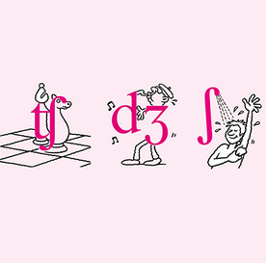
2.I love French cheese and Spanish olives

3.He has a Japanese watch.

4.It's a German technology company.

5.He's a Belgian musician

Accidental inventions: Activity 1
Listen to a radio program about things that have been invented by accident. Choose the correct answers.
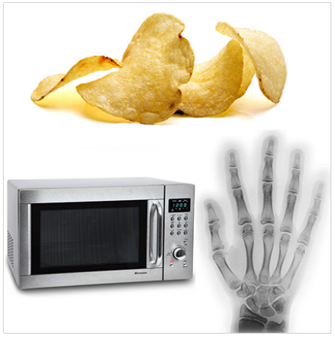
1. The microwave oven was invented by _______ .
- George Crum
- Percy Spencer
- Wilhelm Roentgen
2. The X-ray was invented by _______.
- George Crum
- Percy Spencer
- Wilhelm Roentgen
3. Potato chips were invented by _______.
- George Crum
- Percy Spencer
- Wilhelm Roentgen

Accidental inventions: Activity 2
Listen to the radio program again. Complete the sentences with a word or a number. You can read the audio script to help you.
Audio script
Host Hello, and welcome to the program. Today we have scientist, Doug McLeod, in the studio with us. He’s going to tell us about some of the everyday things we know and love that were invented by accident. Doug?
Doug Hello, Janet. Well, I’m going to start with the microwave oven. In 1945, an engineer named Percy Spencer was testing some new radar equipment. He had a chocolate bar in his pocket, and while he was standing in front of the machine, it melted. After that, he also tried using the microwaves from the radar equipment to cook popcorn. Percy realized that microwaves could heat and cook food, and so the microwave oven was born.
Host How interesting! What else do you have for us, Doug?
Doug Next is something that is found in hospitals all over the world: the x-ray machine. In 1895, a German physicist named Wilhelm Roentgen was experimenting with electrical rays in a dark room. He was directing them through a glass tube covered with black paper. Suddenly, he saw a light on a screen on the wall and he realized that the rays could pass through the glass and the paper. After that, he experimented with his own hand, and found that he could see the bones. The first x-ray ever made was an image of Roentgen’s wife’s hand – you can even see her wedding ring!
Presenter That’s fascinating, Doug. We have time for one more.
Doug Many different kinds of food were discovered by accident, Janet, and I’ve chosen something that we call potato chips, but the British call crisps. These were invented by a chef named George Crum, who was working in a restaurant near Saratoga Springs, New York. A customer complained that the French fries he was served were too thick. The chef was angry about this, so he fried some very thin potatoes and covered them with salt. The customer loved them, and after that Saratoga Chips became popular all over the US. Eventually, they were produced for people to eat at home.
Presenter Thanks for joining us.

1. Percy Spencer discovered that microwaves heated food in the year ________ .
2. The microwaves melted a bar of chocolate in his ________ .
3. Wilhelm Roentgen's nationality was ________ .
4. He discovered that electrical rays could pass through ________ and paper.
5. The image on the first X-ray is of Roentgen's ________ hand.
6. Thin fried potatoes are called "crisps" by the ________.
7. Their inventor was a ________.
8. The chips were first called "Saratoga ________."

Which inventions couldn't you live without?
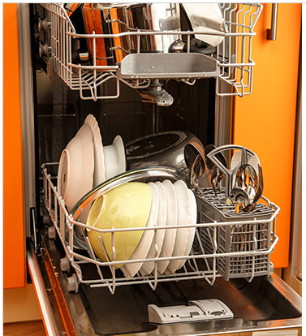 | Apart from your phone, which invention couldn't you live without? Why?  Go to Discussions and share your ideas with your classmates.

