**Present continuous: Activity 1**

Read Grammar Bank 1C. Then write sentences with the present continuous. Use contractions where you can. Listen and check.

|  |
| --- |
| Grammar Bank  **1C** present continuous: *be* + verb + -*ing*  EXAMPLES  **1**  **A** What **are you doing**?  **B** **I'm sending** a message to Sarah.  **2**  My brother **is taking** a two-month vacation in the US.  **3**  In this picture the woman **is standing** near a table.  FORM   * We use the present continuous:   **1**  for things happening now, at this moment.  **2**  for temporary things that are happening around now, this week, etc.  **3**  to describe what's happening in a picture.  [+]  I**’m working**  you / we / they  **’re working**  he / she / it   **’s working**  [–]  I**’m not working**  you / we / they   **aren’t working**  he / she / it   **isn’t working**  [?]                                [✓]               [✗]  **Are** you **working**?    **Yes**, I **am**. / **No**, I**’m not**.  **Is** he **working**?        **Yes**, he **is**. / **No**, he **isn’t**.  SPELLING RULES  cook → cook**ing**, study → study**ing**   add -*ing*  live → liv**ing**   cut the final *e* and add -*ing*  run → runn**ing**   if verb finishes in consonant-vowel-consonant, double the final consonant and add -*ing*. |

|  |  |
| --- | --- |
| **1.**  it / not snow     ___________________________ . **2.**  Oliver / wear a suit today    ___________________________ . **3.** what book / read    ___________________________ ? **4.**  I / plan a trip to the US    ___________________________ . **5.**  you / standing on my foot    ___________________________ . **6.**  they / not getting along very well at the moment    ___________________________ . **7.**  she / wear makeup    ___________________________ ? **8.**  I / not sitting in my usual place today    ___________________________ . |  |

**Present continuous: Activity 2**

Read Grammar Bank 1C. Then choose the correct answers. Listen and check.

|  |
| --- |
| Grammar Bank  **1C** present continuous: *be* + verb + -*ing*  EXAMPLES  **1**  **A** What **are you doing**?  **B** **I'm sending** a message to Sarah.  **2**  My brother **is taking** a two-month vacation in the US.  **3**  In this picture the woman **is standing** near a table.  FORM   * We use the present continuous:   **1**  for things happening now, at this moment.  **2**  for temporary things that are happening around now, this week, etc.  **3**  to describe what's happening in a picture.  [+]  I**’m working**  you / we / they  **’re working**  he / she / it   **’s working**  [–]  I**’m not working**  you / we / they   **aren’t working**  he / she / it   **isn’t working**  [?]                                [✓]               [✗]  **Are** you **working**?    **Yes**, I **am**. / **No**, I**’m not**.  **Is** he **working**?        **Yes**, he **is**. / **No**, he **isn’t**.  SPELLING RULES  cook → cook**ing**, study → study**ing**   add -*ing*  live → liv**ing**   cut the final *e* and add -*ing*  run → runn**ing**   if verb finishes in consonant-vowel-consonant, double the final consonant and add -*ing*. |

**1.** My dog isn't dangerous. He isn't biting / doesn't bite .  
**2.**  Why do you wear / are you wearing sunglasses? It 's raining / rains!  
**3.** You can turn off the radio. I don't listen / 'm not listening to it.  
**4.** I 'm needing / need to find an ATM.  
**5.** **A** Do you usually cook / Are you usually cooking on the weekends?  
     **B** No, we normally eat / 're normally eating out.  
**6.**  Mario lives / is living in Cancun, but he works / 's working in Mexico City at the moment.  
**7.**  I usually drink tea, but I want / 'm wanting coffee today.  
**8.**  **A** What do you do / are you doing here?  
     **B** I 'm waiting / wait for Emma. She's late, as usual.

**Clothes:** **Activity 1**

Listen and read. Match the sentences to the correct picture.

|  |  |
| --- | --- |
| 1. blouse |  |
| 2. cardigan |  |
| 3. coat |  |
| 4. dress |  |
| 5. jacket |  |
| 6. jeans |  |
| 7. leggings |  |
| 8. pajamas |  |
| 9. shirt |  |
| 10. shorts |  |
| 11. skirt |  |
| 12. socks |  |

**Clothes:** **Activity 2**

Match the words to the correct pictures.

|  |
| --- |
| tracksuit ﻿pants T-shirt underwear boots flip flops sandals shoes |

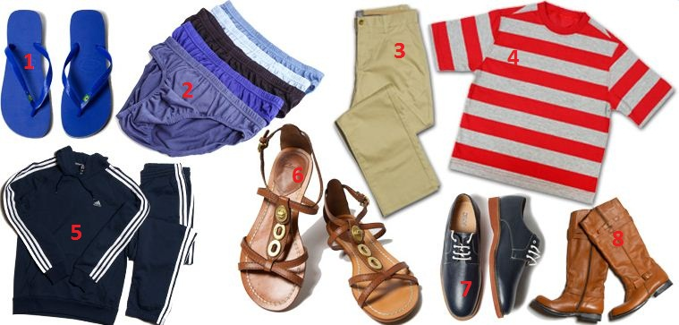

|  |  |  |  |
| --- | --- | --- | --- |
| 1. |  | 5. |  |
| 2. |  | 6. |  |
| 3. |  | 7. |  |
| 4. |  | 8. |  |

**Clothes:** **Activity 3**

Match the pictures to the correct words. Then listen and check.

|  |  |  |
| --- | --- | --- |
| 1.   * tie * hat * top |  |  |
| 2.   * tights * gloves * earrings |  |  |
| 3.   * scarf * belt * ring |  |  |
| 4.   * tie * necklace * suit |  |  |
| 5.   * scarf * bracelet * cap |  |  |
| 6.   * sneak﻿ers * earrings * gloves |  |  |
| 7.   * necklace * sweater * hat |  |  |
| 8.   * coat * ring * bracelet |  |  |

**Prepositions of place**

Look at the picture and choose the correct answers. Then listen and check.

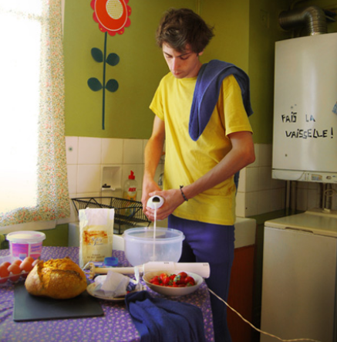

|  |  |
| --- | --- |
| 1. The young man is ______ the kitchen.    * on    * in    * under 2. There's a table ______ him.    * between    * in front of    * behind 3. ______ the table there are some eggs, some bread, and some strawberries.    * On    * Under    * In 4. The bread is in the middle of the table. It's ______ the eggs and the strawberries.    * between    * above    * behind 5. There's a board ______ the bread.    * in    * on    * under 6. ______ the man, there's an old washing machine.    * On the left of    * Behind    * In front of 7. There's a window ______ the photo.    * in the middle of    * next to    * on the left of 8. ______ of the room, there's a sink and some cleaning products.    * In the corner    * In the middle    * Next to 9. There's a flower on the wall ______ the sink.    * between    * above    * behind 10. The sink is ______ the window.     * in the corner of     * next to     * in front of |  |

**/ə/ and /ər/**

Listen and read. Match the word to the correct sound. Then listen and repeat.

|  |  |
| --- | --- |
| 1. paint**er**   * + /ə/   + /ər/ |  |
| 2. h**er**   * + /ə/   + /ər/ |  |
| 3. f**ir**st   * + /ə/   + /ər/ |  |
| 4. phot**o**graph   * + /ə/   + /ər/ |  |
| 5. pict**ure**   * + /ə/   + /ər/ |  |
| 6. pref**er**   * + /ə/   + /ər/ |  |
| 7. c**ur**ly   * + /ə/   + /ər/ |  |
| 8. **a**ttractive   * + /ə/   + /ər/ |  |
| 9. occas**io**n   * + /ə/   + /ər/ |  |
| 10. w**or**k   * + /ə/   + /ər/ |  |
| 11. univ**er**sity   * + /ə/   + /ər/ |  |

**Flower power: Activity 1**

Listen to an advert and choose the correct answers.



|  |  |
| --- | --- |
| 1. The speaker is advertising ______.  * a trip to Paris * a new mobile phone * an art exhibition  1. She talks about a man who ______.  * takes photos of flowers * grows flowers in his garden * makes pictures of flowers  1. The man's name is ______.  * Yves Saint Laurent * David Hockney * Pierre Bergé |  |

**Flower power: Activity 2**

Listen to the advertisement again. Complete the sentences with a word or a number.

|  |  |
| --- | --- |
| 1.  The David Hockney exhibition is in ___________ .  2.  The exhibition is called Fresh ___________ .  3.  Hockney has a beautiful view from his ___________ window.  4.  The first picture he painted with his phone was a ___________ .  5.  The Hockney exhibition finishes on ___________ 30th.  6.  The exhibition costs €___________ . |  |