**Past continuous: Activity 1**

Read Grammar Bank 2B. Then complete the sentences with the correct past continuous form of the verbs. Use contractions where you can. Listen and check.

|  |
| --- |
| Grammar Bank  **2B** past continuous: *was / were* + verb + -*ing*  EXAMPLES  At 8:45 last Saturday I **was walking** in the park.  The birds **were singing**.  It **wasn't raining**.  **A** **Was** it **raining** when you got up?   **B** No, it **wasn't**.  **A** What **were** you **doing** at 11 o'clock last night?   **B** I **was watching** TV.  FORM  [+]  I / He / She / It **was working**.  You / We / They **were working**.  [–]  I / He / She / It **wasn’t working**.  You / We / They **weren’t working**.  [?]                                    [✓]                    [✗] **Was** he **working**?        **Yes**, he **was**. / **No**, he **wasn’t**.  **Were** they **working**?    **Yes**, they **were**. / **No**, they **weren’t**.   * We use the past continuous to describe an action in progress at a specific time in the past. * We often use the past continuous to describe the situation at the beginning of a story, e.g., *In 1972 I was living in London*. |

|  |  |
| --- | --- |
| 1.  I took this photo when ______________ in Thailand. (we / travel)  2.  He met his wife when ______________ in Japan. (he / live)  3.  ______________ a coat when she went out? (she / wear)  4.  ______________ when I went to work. (the sun / shine)  5.  What ______________ at 7:30 last night? (you / do)  6.  ______________ when you gave the instructions. (I / not listen)  7.  ______________ TV when I arrived. (they / not watch)  8.  It started to rain when ______________ in the park. (we / run) |  |

**Past continuous: Activity 2**

Read Grammar Bank 2B. Then choose a simple past and a past continuous form to complete each sentence. Listen and check.

|  |
| --- |
| Grammar Bank  **2B** simple past or past continuous?  EXAMPLES  We **were walking** in the gardens when he **took** a photo of us.  My sister **arrived** when I **was having** lunch.  FORM   * We often use the past continuous and the simple past together in the same sentence. We use the past continuous to talk about a longer action that was happening in the background when the shorter simple past action happened. |

|  |  |
| --- | --- |
| **1.** She was arriving / arrived when we had / were having dinner. **2.**  I was breaking / broke my arm when I played / was playing volleyball. **3.**  Were you driving / Did you drive fast when the police were stopping / stopped you? **4.**  It snowed / was snowing when we were leaving / left the restaurant. **5.**  I wasn't seeing / didn't see the game because I was working / worked. **6.**  When you were calling / called me, I was talking / talked to my boss. **7.**  We studied / were studying English in the US when we were meeting / met . **8.** Were they living / Did they live in Cairo when they were having / had their first baby? |  |

**Time and place: Activity 1**

Match the words to the correct prepositions. Then listen and check.

|  |  |
| --- | --- |
| a park the roof a store a train the airport  Lima a castle a yard a bus stop a shelf  a ship a plane the station home the balcony  the wall the kitchen Peru work school |  |

|  |  |  |
| --- | --- | --- |
| **IN** | **ON** | **AT** |
|  |  |  |

**Time and place: Activity 2**

Complete the phrases with *at*, *in* or *on*. Then listen and check.

|  |  |
| --- | --- |
| 1.  _________ June  2.  _________ March 1st  3.  _________ two-thirty  4.  _________ Valentine's Day  5.  _________ Saturday  6.  _________ the evening  7.  _________ night  8.  _________ New Year's Day  9.  _________ winter  10.  _________ 2020 |  |

**Weak forms: *was, were***

Listen and write the words you hear.

|  |  |
| --- | --- |
| 1.  _________ _________ my first semester in college. |  |
| 2.  I _________ _________ with him on spring break. |  |
| 3.  We _________ _________ a music class. |  |
| 4.  _________ _________ at school together. |  |
| 5.  She took this when we _________ _________ the Colosseum. |  |
| 6.  Roz and I _________ _________ with Mom and David. |  |

**Family photos: Activity 1**

Listen to a conversation between Matt and Jenny about a photo. Choose the correct answers.

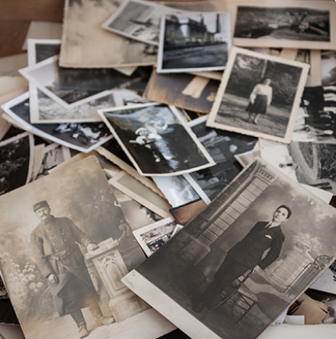

|  |  |
| --- | --- |
| 1. The photo shows Matt's ______.    * parents    * grandparents    * aunt and uncle 2. The people in the photo are ______.    * enjoying their free time    * relaxing at home    * working in a shop 3. Jenny ______ the photo.    * likes    * doesn't like    * doesn't mind |  |

**Family photos: Activity 2**

Listen to the conversation again. Choose the correct answers.

|  |  |
| --- | --- |
| 1.  The photo shows Matt's grandparents after / before / during their wedding.  2.  The photo was taken in the fall / the summer / the spring .  3.  The man wanted to win some money / some food / some jewelery .  4.  The other people in the photo were the man's coworkers / neighbors / friends .  5.  The man on the stall didn't like the photo / wanted more money for the photo / took the photo. |  |

**Writing 2: Describing a photo**

Write a description of an old photo.

|  |  |
| --- | --- |
| Make notes to answer the questions below. Add more information to make the description interesting.  - Who or what is in the photo?  - Who took it? When? Where?  - What was happening when you took the photo?  - Why do you like it?  - Where do you keep it?  **Write five paragraphs.** | Write here … |