**Defining relative clauses: Activity 1**

Read Grammar Bank 3C. Then choose the correct answers. Listen and check.

|  |
| --- |
| Grammar Bank  **3C** defining relative clauses with *who, which, where*  EXAMPLES  **1**  That's the woman **who** won the lottery last year.      A chef is a person **who** cooks food in a restaurant.  **2**  A clock is something **that** tells the time.      Is that the book **that** won an important prize?  **3**  A post office is a place **where** you can buy stamps.      That's the restaurant **where** I had dinner last week.  FORM   * We use defining relative clauses to explain what a person, thing or place is or does.   **1**  Use *who* for a person.  **2**  Use *that* for a thing.  **3**  Use *where* for a place.   * The verb after *where* needs a subject, e.g., *you*. * We can also use *that* to talk about a place, e.g.,   *A post office is a place that sells stamps.* |

|  |  |
| --- | --- |
| 1.  A mail carrier is the person who / where / which brings you your packages and letters.  2.  An octopus is an animal that / who / where lives in the ocean and has eight legs.  3.  A lawnmower is a machine that / who / where cuts the grass.  4.  A surgeon is a doctor which / where / who does operations.  5.  A changing room is a room which / where / who people try on clothes.  6.  A porter is the person which / where / who helps you with your luggage.  7.  A garage is a place which / where / who mechanics repair cars.  8.  Garlic is a vegetable that / who / where has a strong smell. |  |

**Defining relative clauses: Activity 2**

Read Grammar Bank 3C. Then write sentences with *who, that* or *where.* Use contractions where you can. Listen and check.

|  |
| --- |
| Grammar Bank  **3C** defining relative clauses with *who, which, where*  EXAMPLES  **1**  That's the woman**who** won the lottery last year.      A chef is a person **who** cooks food in a restaurant.  **2**  A clock is something **that** tells the time.      Is that the book **that** won an important prize?  **3**  A post office is a place **where** you can buy stamps.      That's the restaurant **where** I had dinner last week.  FORM   * We use defining relative clauses to explain what a person, thing or place is or does.   **1**  Use *who* for a person.  **2**  Use *that* for a thing.  **3**  Use *where* for a place.   * The verb after *where* needs a subject, e.g., *you*. * We can also use *that* to talk about a place, e.g.,   *A post office is a place that sells stamps.* |

|  |  |
| --- | --- |
| **1.**  She / the woman / catches the same bus as me      _______________________________ . **2.**  This / the light / is broken      _______________________________ . **3.** They / the children / live next door to me      _______________________________ . **4.**  This / the restaurant / they make great pizza      _______________________________ . **5.** That / the room / we have our meetings      _______________________________ . **6.**  He / the teacher / teaches my sister      _______________________________ . **7.**  That / the switch / controls the air conditioning      _______________________________ . **8.**  That / the store / I bought my wedding dress      _______________________________ . |  |

**Paraphrasing: Activity 1**

Match 1–8 to a–h to make definitions. Then listen and check.

|  |  |
| --- | --- |
| **1.**  It's somebody   ___ **2.**  It's something   ___ **3.**  It's somehere   ___ **4.**  It's a kind of   ___ **5.** It's the opposite   ___ **6.**  It's like   ___ **7.** It's similar   ___ **8.**  It's a verb. For example,   ___  **a**  to a wallet, but it's for a woman. **b**  who shows you around a city or a museum. **c**  a sweater, but it has buttons. **d**  you do this to the TV when you've finished watching something. **e**  where people go when they want to send a package or a letter. **f**  that we use to pay, instead of cash. **g**  of expensive. **h**  fruit. It's long and yellow. |  |

**Paraphrasing: Activity 2**

Complete the definitions with the words in the box. Then listen and check.

|  |  |
| --- | --- |
| like something similar example opposite  kind somewhere somebody |  |

1.  It's the __________ of generous.   CHEAP

2.  They're __________ to sandals, but they're for the swimming pool.   FLIP-FLOPS

3.  It's __________ who designs buildings.   ARCHITECT

4.  It's a verb. For __________ , you do this when you want to use a bike for an hour.   RENT

5.  It's a __________ of hat that protects your face from the sun.   CAP

6.  It's __________ a house, but it's smaller and you usualy rent it.   APARTMENT

7.  It's __________ where you go to see a play.   THEATER

8.  It's __________ that we buy when we're on vacation.   SOUVENIR

**Silent *e***

Listen and write the words you hear. Then listen and repeat.

|  |  |
| --- | --- |
| 1. ___________ |  |
| 1. ___________ |  |
| 1. ___________ |  |
| 1. ___________ |  |
| 1. ___________ |  |
| 1. ___________ |  |

**Word games: Activity 1**

Listen to a radio program about the word game *Scrabble*. Choose the correct answers.

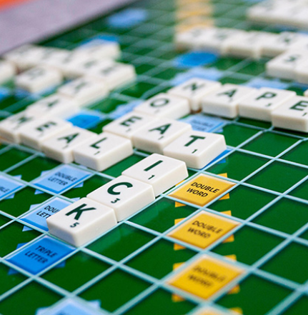

|  |  |
| --- | --- |
| 1. *Scrabble* was invented in ______.    * Australia    * the UK    * the US 2. *Scrabble* has had ______ different names.    * two    * four    * three 3. *Scrabble* has the same ______ as the first version of the game.    * board    * tiles    * rules |  |

**Word games: Activity 2**

Listen to the radio program again. Read the sentences and write T (true) or F (false).

|  |  |
| --- | --- |
| 1.  Alfred Mosher Butts was out of work when he invented the game.   ___  2.  The game of *Lexico* had a board and letter tiles. ___  3.  Butts used a newspaper to count the frequency of the letters in English. ___  4.  Butts gave the letters *A, E, I, O* and *U* one point each.   ___  5.  Butt gave 12 points to the most difficult letters to use.   ___  6.  *Scrabble* became popular in 1948.   ___  7.  Butts and Brunot sold the rights to the game to another manufacturer.   ___  8.  You can buy *Scrabble* in more than two hundred different countries.   ___ |  |