**Superlatives: Activity 1**

Read Grammar Bank 5B. Then complete the sentences with a superlative. Listen and check.

|  |
| --- |
| Grammar Bank  **5B** superlatives  EXAMPLES  **1**  Tokyo is **the cleanest** city in the world.      Spain is one of **the most popular** vacation destinations.      Camping is **the least expensive** way to go on vacation.  **2**  It's **the most beautiful** city **I've ever been to**.      It's **the best** movie **I've seen** this year.  FORM  **1** We use *the* + superlative adjectives to say which is the biggest*,* etc. in a group.   * After superlatives we use *in* + names of places or singular words for groups of people, e.g.,   *It's* ***the noisiest*** *city* ***in*** *the world. Ann's* ***the oldest in*** *the class.*   * We can also use *the least* + adjective, e.g., *the least expensive* OR *the cheapest*.   **2** We often use *the* + superlative with the present perfect + *ever*.  SPELLING RULES   * one-syllable adjectives: + -*est* or *-st*, e.g., ***the*** *cold****est*** * adjectives ending in one vowel + one consonant: double consonant + -*est,*e.g., ***the*** *thin****nest.*** * one- or two-syllable adjectives ending in consonant + *y*: change *y* to *i* + -*est,*e.g., ***the****health****iest***. * one-syllable adjectives ending in -*ed*: *the most* + adjective, e.g., ***the******most****tired,* * two- or more-syllable adjectives: *the most* + adjective, e.g., ***the most****beautiful.* * irregular: *good →****the best***; *bad →****the worst***; *far →****the farthest***﻿(the furthest). |

|  |  |
| --- | --- |
| 1.  Is Shanghai _________ city in the world? (big)  2.  They are _________ people I know. (generous)  3.  Early morning is _________ time to drive downtown. (bad)  4.  She's _________ girl in school. (friendly)  5.  _________ I've ever flown is to Brazil. (far)  6.  Yesterday was _________ day of the year. (hot)  7.  _________ time to visit New England is in fall. (good)  8.  This is _________ part of the exam. (important) |  |

**Superlatives: Activity 2**

Read Grammar Bank 5B. Then write sentences with a superlative + *ever* + the present perfect. Use contractions. Listen and check.

|  |
| --- |
| Grammar Bank  **5B** superlatives  EXAMPLES  **1**  Tokyo is **the cleanest** city in the world.      Spain is one of **the most popular** vacation destinations.      Camping is **the least expensive** way to go on vacation.  **2**  It's **the most beautiful** city **I've ever been to**.      It's **the best** movie **I've seen** this year.  FORM  **1** We use *the* + superlative adjectives to say which is the biggest*,*etc. in a group.   * After superlatives we use *in* + names of places or singular words for groups of people, e.g.,   *It's****the noisiest****city****in****the world. Ann's****the oldest in****the class.*   * We can also use *the least* + adjective, e.g., *the least expensive* OR *the cheapest*.   **2** We often use *the* + superlative with the present perfect + *ever*.  SPELLING RULES   * one-syllable adjectives: + -*est* or *-st*, e.g., ***the****cold****est*** * adjectives ending in one vowel + one consonant: double consonant + -*est,*e.g., ***the****thin****nest.*** * one- or two-syllable adjectives ending in consonant + *y*: change *y* to *i* + -*est,*e.g., ***the****health****iest***. * one-syllable adjectives ending in -*ed*: *the most* + adjective, e.g., ***the******most****tired,* * two- or more-syllable adjectives: *the most* + adjective, e.g., ***the most****beautiful.* * irregular: *good →****the best***; *bad →****the worst***; *far →****the farthest***﻿(the furthest). |

|  |  |
| --- | --- |
| **1.**  It / exciting job / I / do      _______________________________ . **2.** This / long book / I / read      _______________________________ . **3.** It / good movie / I / see      _______________________________ . **4.** He / attractive man / I / meet      _______________________________ . **5.** It / hot place / I / be to      _______________________________ . **6.**  She / interesting teacher / I / have      _______________________________ . **7.**  It / easy exam / I / do      _______________________________ . **8.**  It / bad meal / I eat      _______________________________ . |  |

**Describing a town or city: Activity 1**

Look at the map. Then read the sentences about York and choose the correct answers. Listen and check.

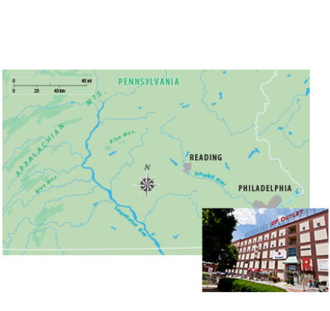

|  |  |
| --- | --- |
| * 1. Reading is a city in the ______ of the state of Pennsylvania in the US.   + east   + west   1. It's located ______.   + in the mountains   + on the Schuykill River   1. It is about 60 miles ______ of Philadelphia.   + east   + west   1. It is a ______ city, and it has a population of about 88,000.   + large   + small   1. It is famous for its __________ , which were the first in the US.   + discount outlet shopping malls   + shoppings   + discount |  |

**Describing a town or city: Activity 2**

Match the adjectives cards to their opposites.

|  |
| --- |
| noisy modern boring crowded dangerous polluted |

|  |  |  |  |
| --- | --- | --- | --- |
| quiet |  | historic |  |
| exciting / interesting |  | safe |  |
| empty |  | clean |  |

**Describing a town or city: Activity 3**

Put the words into the correct boxes. Then listen and check.

|  |  |
| --- | --- |
| ruins statue castle harbor canal lake town hall department store hill bridge market palace museum shopping  mall city walls |  |

|  |  |  |
| --- | --- | --- |
| Places where you can buy things | Historic buildings and monuments | Others |
|  |  |  |

**Sentence stress**

Listen and write the words you hear. Then listen and repeat. Try to copy the rhythm.

|  |  |
| --- | --- |
| 1.  What's the _________ _________ city you've ever been to? |  |
| 2.  What's the _________ _________ vacation you've ever had? |  |
| 3.  What's the _________ _________ movie you've ever seen? |  |
| 4.  What's the _________ _________ sporting event you've ever watched? |  |
| 5.  What's the _________ _________ thing you've ever bought? |  |
| 6.  Who's the _________ _________ person you've ever met? |  |
| 7.  What's the _________ _________ sport you've ever played? |  |
| 8.  What's the _________ _________ subject you've ever studied? |  |

**Visiting Brazil: Activity 1**

Listen to a radio travel program about Brazil. Check the places that are mentioned in the program.

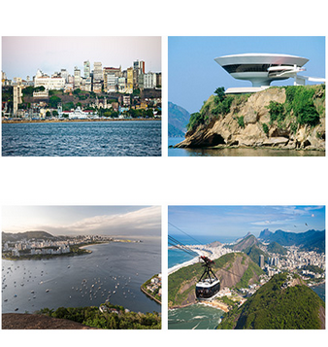

|  |  |
| --- | --- |
| * Búzios * Salvador * Brasília * Rio de Janeiro * São Paulo * Recife |  |

**Visiting Brazil: Activity 2**

Listen again and answer T (true) or F (false).

|  |  |
| --- | --- |
| 1.  Salvador is an old city. ____  2.  Eight million people live in Rio de Janeiro. ____  3.  The churches in Rio de Janeiro are all very new. ____  4.  You can take a bus to visit the peninsula. ____  5.  The best time to visit is December to March.  ____ |  |

**Writing 4: Describing where you live**

Write a description of a place where you would like to live.

|  |  |
| --- | --- |
| Think of a city or town where you would like to live. Make notes to answer the questions below. Add more information to make the description interesting.  - Where would you like to live? Where is it? How big is it?  - What's the place like? What is there to see there?  - What's the weather like?  - What's it famous for?  - What's the best thing about this place? Why would you like to live there?  **Write five paragraphs.** | Write here… |