Grammar test

Choose the correct options to complete the sentences.

1. The first modern bicycle _______ in Germany in 1817.
- made
- is made
- was made
2. You never wear those shoes. You should _______.
- throw it away
- throw them away
- throw away them
3. "James isn't in the office. Where is he?" "He's _______ for a coffee."
- gone out
- gone out of
- come out
4. I've scheduled a taxi for tomorrow. It's going to _______ at 6:00 a.m.
- pick us up
- pick up
- pick up us
5. "When _______ the first plastic made?" "In 1907, I think."
- is
- was
- did
6. We _______ Main Street and parked outside the bank.
- drove under
- drove along
- drove around
7. I have a little sister. I've promised to _______ tonight because my parents are going out.
- look after her
- look after
- look her after
8. _______ and close the door. We don't want anyone to hear us.
- Come into
- Come in
- Go into
9. "How_______ ?" "Usually with milk, cream and fruit."
- is made ice cream
- is ice cream made
- does ice cream made
10. The first computer code _______ Ada Lovelace in 1842–43.
- is written by
- was written by
- wrote for
11. I'm late because my alarm didn't _______ this morning.
- go off it
- go it off
- go off
12. It was dark when we _______ the forest, and we nearly got lost.
- walked across
- walked through
- walked along

Vocabulary test
Choose the correct options to complete the sentences.

1. Could you ______ your music a bit? I'm trying to read.
- turn on
- turn down
- turn up
2. The ball went ______ our heads and into the yard next door.
- over
- across
- through
3. The ______ are famous for their delicious chocolate.
- Belgium
- Belgians
- Belgian
4. "Children, ______ your shoes, and leave them by the door."
- take on
- take off
- put off
5. If you want to go to the park, ______ the bus on Broad Street.
- get away
- get out
- get off
6. People from Germany are known as ______.
- the Dutch
- the Germans
- the German
7. Please come ______! I didn't mean what I said.
- back
- across
- towards
8. Silk was invented by ______.
- Chinese
- China
- the Chinese
9. Ameena has decided to ______ junk food and exercise more this year.
- give out
- give in
- give up
10. My dog suddenly ran ______ the road – luckily there weren't any cars coming.
- through
- past
- across
11. Toothpaste was invented by the ______.
- Egyptian
- Egypt
- Egyptians
12. Can you ______ your clothes, please? I want to clean the floor.
- put up
- pick up
- give up

Dictation
Listen and write what you hear . Write the numbers in words.
- Tom spends most nights ______ ______ ______ ______ because ______ ______ _______ _______ .
- He ______ ______ ______ ______ , and then _______ ________ _______ ________ his children at lunchtime.
- After lunch _______ _______ _______ ________ _______ _______ _______ _______ .
- _______ _______ _______ _______ _______ _______ , he finds it hard to get out of bed.
- But _______ _______ ________ his work hours, he ________ ________ ________ _________ money.
- Tom meets _______ _______ _______ _______ , but his favorite customers _______ _______ _______ because ________ ________ ________ ________ ________ .

Challenge
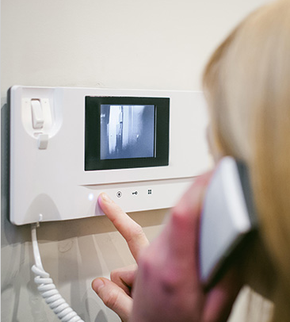 | Go online and research recent inventions. Choose an invention and write a paragraph about it to share in class. Include information about:  - What is the invention and who was it invented by?  - What does it do?  - What does it look like?  Go to Discussions and share your ideas with your classmates.

