Grammar test

Choose the correct options to complete the sentences.

- If ______ more time, I'd learn how to paint.
- I'd have
- I have
- I had
- "______ has Andrea lived in Mexico City?" "For about six years."
- How long
- How often
- When
- Tina's been a chef at the Hilton Hotel ______ 12 years. She loves her job.
- ago
- for
- since
- John Lennon ______ the song "Imagine" in 1971.
- has written
- wrote
- would write
- "How many children ______?" "Eleven!"
- has Bob Marley had
- has Bob Marley
- did Bob Marley have
- "What ______ say if you met your favorite singer?" "I don't know – I'd probably be too shy to speak."
- do you
- would you
- you would
- Zambia has been an independent country ______ 1964.
- for
- since
- ago
- If ______, I'd get a new laptop. Yours is much too slow.
- I'd be you
- I was you
- I were you
- "When ______ India?" "In 2012 – it was an amazing vacation."
- did you go to
- have you been to
- do you go to
- Ken ______ a phobia of lifts since he was a child.
- had
- has had
- has
- If we had a dog, we ______ take it for long walks in the park.
- could
- can
- will
- "How long ______ Dora?" "For about 10 years – we met at the gym."
- do you know
- have you known
- you know

Vocabulary test
Choose the correct options to complete the sentences.
1. When I was a child, we got milk from my grandfather's ______.
- bulls
- chickens
- cows
2. "Scared" means ______
- frightened
- stressed
- worried
3. If I saw a ______, I'd get out of the water incredibly quickly.
- goat
- dolphin
- shark
4. When it's getting dark, I often see ______ flying near my house.
- bats
- spiders
- bees
5.My grandfather______ when he was 67 and went to live in Florida.
- retired
- died
- had children
6. I'm going to Kenya on safari, and I'd like to see a ______.
- whale
- giraffe
- bear
7. My sister is ______ of flying. She always travels by train.
- terrified
- dizzy
- fear
8. My brother ______ and went to college when he was 18.
- graduate from high school
- graduated from high school
- separated
9. Susan ______ to college last September, and she really enjoyed her first year.
- started
- left
- went
10. Debbie's been my best friend for ______.
- 2000
- I was a child
- a long time
11. William ______ in 1994.
- was born
- born
- is born
12. We met last October, and we've been together since ______.
- ten months
- a long time
- then

Dictation
Listen and write what you hear about Bob Marley and Ziggy. Write the numbers as words.

1. Bob Marley ______ ______ ______ ______ ______ ______ in Jamaica.
2. When ______ ______ ______ , he ______ ______ ______ ______ and started ______ ______ .
3. He ______ ______ ______ ______ with his band, and together ______ ______ ______ ______ .
4. In 1966, ______ ______ ______ and ______ ______ ______ they had their son Ziggy.
5. When Ziggy ______ ______ , ______ ______ ______ of cancer.
6. Ziggy ______ ______ ______ ______ ______ ______ ______ his first guitar at age ten.
7. ______ ______ ______ ______ ______ ______ ______ ______ ______ Bob Marley? Nobody knows.

Challenge

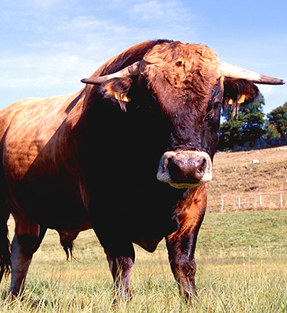 | Go online and research dangerous animals. Choose one animal and write a paragraph about it to share in class. Include information about:  - How big is the animal?  - Where does it live?  - Why is it dangerous?  Go to Discussions and share your ideas with your classmates.

