Vocabulary and Interactive Video
Listen and read. Match the pictures to the correct phrases.
Turn right  at the  traffic lights. | Go around the traffic circle and take the third exit. | Take the  second turn  on the right. | Turn left. | Go straight ahead.

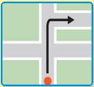 | 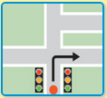 | 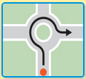 | 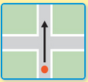 | 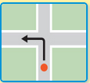

You hear / you say
Watch the video of Rob going to a pharmacy. Try to remember what he says. You can read the video script to help you. Then record Rob's part of the conversation.
Rob: How do I get to Greenwich Village on the subway?
Jenny: Go to the subway station at Prospect Park. Take the B train to West 4th Street.
Rob: How many stops is that?
Jenny: Six or seven.
Rob: OK. And then?
Jenny: From West 4th Street take the A train, and get off at 14th Street.
Rob: Could you say that again?
Jenny: OK. From Prospect Park take the B train to West 4th Street, and then take the A train to 14th Street. That’s only one stop.
Rob: Where’s the restaurant?
Jenny: Come out of the subway on Eighth Avenue, go straight on for about 50 yards and take the first left. That’s Greenwich Avenue. The restaurant’s on the right. It’s called The Tea Set.
Rob: OK, thanks. See you later.
Jenny: And don’t get lost!

Social English phrases
Watch the Social English phrases. Then record yourself saying them.
Rob: I’m so sorry.
Rob: I said I’m sorry.
Jenny: I don’t feel like a walk.
Jenny: It’s been a long day.
Jenny: I didn’t mean to say that.

