**Expressing movement: Activity 1**

1. to-into
2. past
3. along
4. over
5. towards
6. over-into
7. around
8. across

**Expressing movement: Activity 2**

1.  into

2.  over

3.  in

4.  up

5.  out

6.  out of

7.  away

8.  down

**Sports**

|  |  |  |
| --- | --- | --- |
| **play** | **go** | **do** |
| baseball  basketball  soccer  handball  rugby  tennis  volleyball | cycling  skiing  windsurfing | track and field  gymnastics  karate  yoga |

**Expressing movement: Activity 1**

|  |  |  |
| --- | --- | --- |
|  | under the bridge |  |
|  | along the street |  |
|  | around the lake |  |
|  | through the tunnel |  |
|  | into the store |  |
|  | across the road |  |

**Expressing movement: Activity 2**

1. 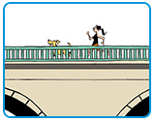
2. 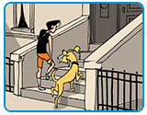
3. 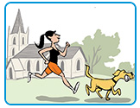
4. 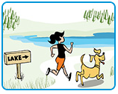
5. 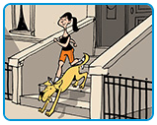
6. 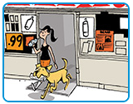

**Word stress**

1. first
2. first
3. first
4. first
5. first
6. second
7. first
8. second
9. first
10. first
11. first
12. first

**Bad losers: Activity 1**

* cards
* tennis
* ice hockey
* board games
* basketball

**Bad losers: Activity 2**

Speaker **1**  : C  
Speaker **2**  :  A  
Speaker **3**  :  E  
Speaker **4**  :  D  
Speaker **5**  :  B