**Word order of phrasal verbs: Activity 1**

1. look after my little sister
2. go out this evening
3. both
4. looking for a new job
5. both
6. try them on
7. both
8. get along with her
9. take it back
10. get up in the morning

**Word order of phrasal verbs: Activity 2**

1. them up
2. it on
3. it up
4. them out
5. it back
6. it on

**Phrasal verbs: Activity 1**

|  |  |  |  |  |  |
| --- | --- | --- | --- | --- | --- |
|  |  |  |  |  |  |
| The game will  be over at  about 5:30. | My alarm goes off at six o'clock every morning. | We set off  for the airport  at 6:30. | I want to give up chocolate. | Don't throw away that letter! | Turn down the music! It's very loud. |
|  |  |  |  |  |  |

**Phrasal verbs: Activity 2**

1. 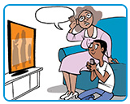
2. 
3. 
4. 
5. 
6. 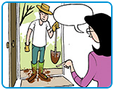
7. 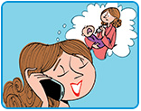
8. 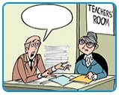

**Linking**

1.  turn it off

2.  pick it up

3.  look it up

4.  put it on

5.  look after it

6.  Take it off

**Still tired in the morning? Activity 1**

1. Sleep at the same times
2. Make sure you are exposed to light during the day
3. Create a relaxing routine before going to bed
4. Avoid stimulants
5. Getting back to sleep

**Still tired in the morning? Activity 2**

1. G
2. B
3. B
4. B
5. B
6. B
7. G
8. B
9. G
10. G