***used to / didn't use to*: Activity 1**

1. He used to be
2. He used to have
3. He didn't use to wear
4. He didn't use to have
5. He used to play
6. He didn't use to wear

***used to / didn't use to*: Activity 2**

1. Angie used to hate math
2. Did you use to work
3. I didn't use to like reading
4. What did you use to do in the summer
5. Americans didn't use to cook with olive oil
6. This restaurant used to be a movie theater
7. Did your sister use to eat meat
8. I didn't use to be interested in sports

**School subjects**

1. 
2. 
3. 
4. 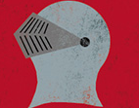
5. 
6. 
7. 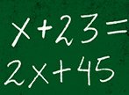
8. 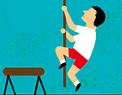
9. 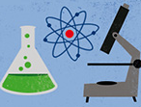

**School subjects**

|  |  |
| --- | --- |
| 1. the study of things like heat, sound, and light | physics |
| 2. the study of the earth and its mountains, rivers, land, and people | geography |
| 3. the study of the life of animals and plants | biology |
| 4. the study of books, plays, and poetry | literature |
| 5. the study of things that happened in the past | history |
| 6. the study of gases, liquids and solids to find out what they are | chemistry |
| 7. the study of paintings, sculptures, etc., and how they are created | art |
| 8. the study of numbers, measurements, and shapes | math |

**Interview with an actor: Activity 1**

1. Where did you go to school?
2. What's the most important lesson you learned at school?
3. Did you ever behave badly?
4. What subjects were you good at?
5. What did you want to do when you left school?
6. Did you have a favorite teacher?

**Expressing movement: Activity 2**

1. True
2. False
3. False
4. True
5. True
6. True
7. False
8. False