**Present continuous: Activity 1**

1. It isn't snowing
2. Oliver's wearing a suit today
3. What book are you reading
4. I'm planning a trip to the US
5. You're standing on my foot
6. They aren't getting along very well at the moment
7. Is she wearing makeup
8. I'm not sitting in my usual place today

**Present continuous: Activity 2**

**1.** My dog isn't dangerous. He doesn't bite .  
**2.**  Why are you wearing sunglasses? It 's raining !  
**3.** You can turn off the radio. I 'm not listening to it.  
**4.** I need to find an ATM.  
**5.** **A** Do you usually cook on the weekends?  
     **B** No, we normally eat out.  
**6.**  Mario lives in Cancun, but he 's working in Mexico City at the moment.  
**7.**  I usually drink tea, but I want coffee today.  
**8.**  **A** What are you doing here?  
     **B** I 'm waiting for Emma. She's late, as usual.

**Clothes:** **Activity 1**

1. 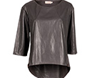
2. 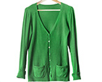
3. 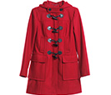
4. 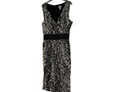
5. 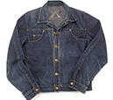
6. 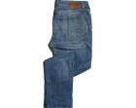
7. 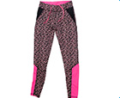
8. 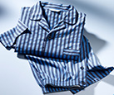
9. 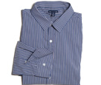
10. 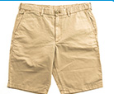
11. 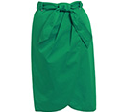
12. 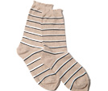

**Clothes:** **Activity 2**

|  |  |  |  |
| --- | --- | --- | --- |
| 1. | flip flops | 5. | tracksuit |
| 2. | underwear | 6. | sandals |
| 3. | pants | 7. | shoes |
| 4. | T-shirt | 8. | boots |

**Clothes:** **Activity 3**

1. hat
2. gloves
3. scarf
4. tie
5. bracelet
6. earrings
7. necklace
8. ring

**Prepositions of place**

1. in
2. in front of
3. On
4. between
5. under
6. Behind
7. on the left of
8. In the corner
9. above
10. next to

**/ə/ and /ər/**

1. /ər/
2. /ər/
3. /ər/
4. /ə/
5. /ər/
6. /ər/
7. /ər/
8. /ə/
9. /ə/
10. /ər/
11. /ər/

**Flower power: Activity 1**

1. an art exhibition
2. makes pictures of flowers
3. David Hockney

**Flower power: Activity 2**

1. Paris
2. Flowers
3. bedroom
4. sunrise
5. January
6. 5