**Simple past: regular and irregular verbs: Activity 1**

Two summers ago, we went (go) on vacation to Canada. We drove (drive) there from Chicago, but our car broke (break) down on the highway, and we spent (spend) the first night in Detroit. When we got (get) to Toronto, we went (go) to our hotel, but they couldn't (not can) find our reservation, and they were (be)  full. We didn't know (not know) what to do, but in the end, we found (find) a Bed and Breakfast, and we stayed (stay) there for the week. We saw (see) the Casa Loma castle and bought (buy) a lot of souvenirs.  We  wanted (want) to go to Niagara Falls, but we  didn't have (not have) much time, and it was (be) about an hour and a half away. The weather wasn't (not be) very good – it started (start) raining on the day we left (leave) Chicago, and it never  stopped (stop)!

**Simple past: regular and irregular verbs: Activity 2**

1. Where did you go
2. Did you have
3. Who did you go
4. Where did you stay
5. How much did the plane tickets cost
6. What was
7. Where did you go
8. How long were you

**Vacations: Activity 1**

1. 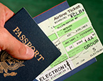
2. 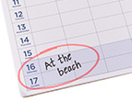
3. 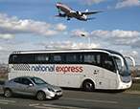
4. 
5. 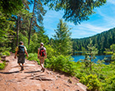
6. 
7. 
8. 
9. 
10. 

**Vacations: Activity 2**

1. stay
2. take
3. buy
4. sunbathe
5. have
6. spend
7. rent
8. book

**Vacations: Activity 3**

2 It was comfortable / luxurious.   It was basic / dirty / uncomfortable.  
4 They were friendly / helpful.   They were unfriendly / unhelpful.  
3 It was beautiful / nice.   It was noisy / crowded.  
1 It was warm / sunny.    It was very windy / foggy / cloudy.

**Regular verbs: *-ed* endings**

* decid**ed**
* rent**ed**
* start**ed**
* want**ed**

**Vacations: Activity 1**

1. They didn't enjoy their vacation.
2. They didn't want to be there.

**Vacations: Activity 2**

Speaker **1**   b  
Speaker **2**   a  
Speaker **3**   c  
Speaker **4**   e  
Speaker **5**   d