Quantifiers: Activity 1
1. I don't eat enough vegetables .
2. I can't come. I'm too busy.
3. I eat too many chips.
4. Do you drink enough water ?
5. This suitcase isn't big enough .
6. I eat too much chocolate.
7. I worry too much .
8. You're always at home. You don't go out enough .
Quantifiers: Activity 2
- enough
- too
- too many
- too much
- too much
- too
- enough
- too many
Health and the body: Activity 1
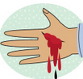
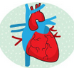
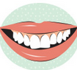
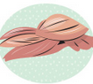
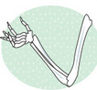
Health and the body: Activity 2
bones |  | blood
blood pressure |  | muscles
heart attack |  | heart
teeth

/ʌ/
- butter
- study
- much
- young
- money
- muscle
- sunny
- blood
- double
- lunch
- country
- funny

Five a day: Activity 1
- give information
- who don't eat enough fruits and vegetables
- Potatoes
Five a day: Activity 2
- True
- False
- True
- False
- True
- False
- False
- True

