***should / shouldn't*: Activity 1**

1. shouldn't
2. should
3. should
4. shouldn't
5. should
6. should
7. should
8. shouldn't

***should / shouldn't*: Activity 2**

1. should wear
2. should study
3. should plan
4. shouldn't be
5. should relax
6. shouldn't drive
7. should spend
8. shouldn't give

***get*: Activity 1**

1. 
2. 
3. 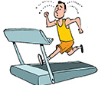
4. 
5. 
6. 
7. 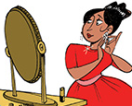
8. 
9. 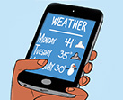
10. 
11. 
12. 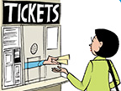

***get*: Activity 2**

1. get into a car
2. get on a bus
3. get along with (somebody)
4. get up
5. get home
6. get to school
7. get to work
8. get an email

**/ʊ/ and /u/**

1.  bull /ʊ/      should   would    good   put

2.  boot /u/      choose     do truth you

**Don't like to talk about your feelings: Activity 1**

1. Problem B
2. Problem C
3. Problem A

**Don't like to talk about your feelings: Activity 2**

1. C
2. B
3. C
4. a
5. B
6. a