Simple present and continuous
Read Grammar Bank 1A. Then choose the correct form, simple present or present continuous.
Listen and check.

Grammar Bank
1A simple present and continuous
simple present: I live, he works, etc.
EXAMPLES
1 I live in New York. She works in a restaurant.
We don’t eat meat. Jack doesn’t wear glasses.
Where do you live? Does the supermarket open on Sundays?
2 She usually has cereal for breakfast.
I’m never late for work.
We only eat out about once a month.
FORM
1 We use the simple present for things that are always true, or happen
regularly.
• Remember the spelling rules for third person singular, e.g., lives, studies, watches.
• Remember the word order for questions: (question word), auxiliary,subject, base form of verb.
Do you know David? What time does the movie start?
2 We often use the simple present with adverbs of frequency, e.g.,
usually, never, or expressions of frequency, e.g., every day, once a
week.
• Adverbs of frequency go before the main verb and after be.
• Expressions of frequency usually go at the end of the sentence or verb phrase.
present continuous: be + verb + -ing
EXAMPLES
A Is your sister still going out with Adam?
B No, they broke up. She isn’t going out with anyone now.
The phone’s ringing. Can you answer it?
House prices are going up very fast right now.
FORM
• We use the present continuous (NOT the simple present) for actions in progress at the time of speaking, e.g., things that are happening now or around now. These are normally temporary, not habitual, actions.
• Remember the spelling rules, e.g., living, studying, getting.
• We also use the present continuous for future arrangements (see 1B).

1. Come on, let's order. The waiter is coming / comes .
2. The head chef is sick, so he isn't working / doesn't worktoday.
3. I am calling / call my sister in New York once a week.
4. What do you usually do / are you usually doing for lunch?
5. I didn't use to like oily fish, but now I love / I'm loving it.
6. We live in the same apartment building, but we never see / never are seeing each other.
7. We aren't going / don't go to Chinese restaurants very often.
8. Can she call you back? She's talking / She talks to a customer right now.
9. The bill seems / is seeming very expensive to me.
10. Do we need / Are we needing to go shopping today?

Action and nonaction verbs
Read Grammar Bank 1A. Then complete the sentences with the simple present or present continuous forms of the verbs in parentheses. See Tools for Quick tips. Listen and check.
Grammar Bank
1A simple present and continuous, action and non-action verbs
action and non-action verbs
EXAMPLES
A What are you looking for?
B My car keys.
A I’ll help you in a moment.
B But I need them now!
A What are you cooking? It smells delicious.
B I’m making pasta.
A Great! I love pasta.
FORM
• Verbs which describe actions, e.g., cook, make, can be used in the present simple or continuous. I’m making lunch. I usually make lunch on the weekend.
• Verbs which describe states or feelings (NOT actions), e.g., be, need, love, are non-action verbs. They are not usually used in the present continuous, even if we mean "now."
• Common non-action verbs are agree, be, believe, belong, depend, forget, hate, hear, know, like, love, matter, mean, need, prefer, realize, recognize, remember, seem, suppose, want.
• Verbs of the senses are normally also non-action, e.g., look, smell, taste, and sound.

1. I _________ high cholesterol so I never _________ fried food. (have, eat)
2. _________ your boyfriend _________ how to cook fish? (know)
3. You _________ sad. What _________ you _________ about? (look, think)
4. What _________ your husband _________ ? It _________ delicious! (cook, smell)
5. Jack _________ to go out tonight. He _________ a quiet night. (not want, have)
6. I _________ the diet in my country _________ worse. (think, get)
7. How often _________ you _________ seafood? (have)
8. I _________ this cake! It _________ like one my mother used to make me. (love, taste)
9. _________ you _________ any vitamins right now? (take)
10. We _________ curry tonight because Sue _________ spicy food. (not make, not like)

Food and cooking: Activity 1
Listen and read. Match the word to the correct number.
1. crab
- 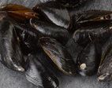
- 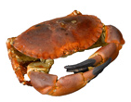
- 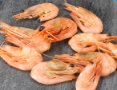
2. lobster
- 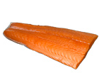
- 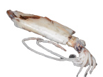
- 
3. mussels
- 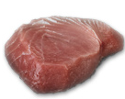
4. shrimp
5. salmon
6. squid
7. tuna
8. beef
- 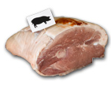
- 
- 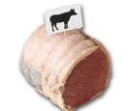
9. chicken
- 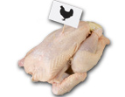
10. duck
- 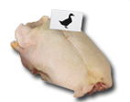
11. lamb
12.pork

Food and cooking: Activity 2
Listen and read. Match the fruit and vegetable words to the correct pictures.
1. egg﻿plant
- 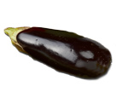
- 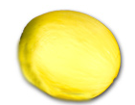
- 
2. avocado
- 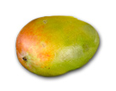
- 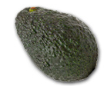
3. cabbage
- 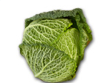
- 
- 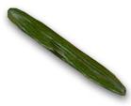
4. cucumber
- 
5. grapes
- 
- 
6. green beans
- 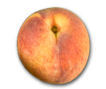
7. lemon
8. mango
9. melon
10. peach
11. pear
12. red pepper

Food and cooking: Activity 3
Listen and read. Match the pictures to the correct cooking words.
 |  | 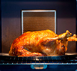
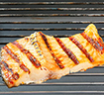 |  | 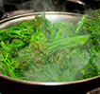

Vowel sounds
Listen to the phrases in the list. Match them to the correct sound picture.
Then listen again and repeat.
crab salad tuna with zucchini a large carton of milk
steamed green beans grilled squid a good cook
hot sausages four forks

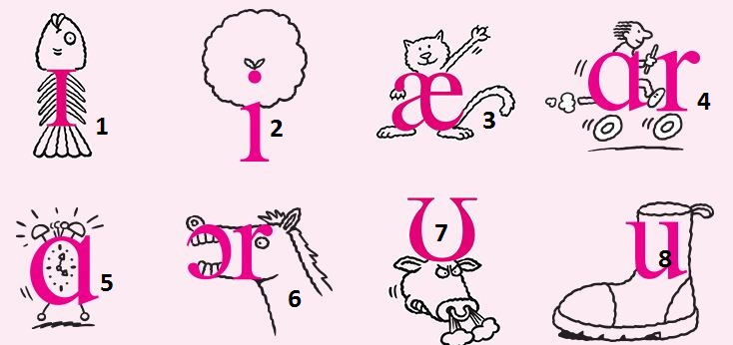

1. |  | 5.
2. |  | 6.
3. |  | 7.
4. |  | 8.

The truth about healthy eating: Activity 1
Read the article and choose the correct heading for each numbered paragraph.
The truth about healthy eating
Food experts are always telling us what we should and shouldn’t eat, but they often give us different advice. Our food writer, Teresa Gold, has taken a look at all the information to figure out what is fact and what is fiction.
1 _______________
A typical American breakfast of fried eggs, bacon, toast, pancakes, and orange juice will certainly stop you from feeling hungry, but it’s high in calories, which means that you’ll gain weight if you eat it regularly. A healthier option is to have just an egg. Boil it instead of frying it, and eat it with a piece of toast made with whole-wheat bread. Breakfast cereals are very high in sugar, so if you feel like cereal, have granola – with no added sugar. You can also get your first vitamins of the day by drinking a glass of freshly squeezed orange juice.
2 _______________
Fruits and vegetables contain the vitamins and minerals we need to stay healthy. But five is actually a fictional number thought up by an American nutritionist. She looked at what the average person ate and doubled it. According to more recent research, the right number is actually eight. The research shows that people who have eight pieces of fruit and vegetables a day are much less likely to suffer from heart disease than those who eat three.
3 _______________
This particular fruit has had some bad publicity because dentists say it can harm our teeth. While it’s true that apples do contain a little sugar, they are also a source of fiber. Nutritionists say that we need about 18 grams of fiber a day, and a medium apple – peel included – contains about 3 grams. Some varieties contain more fiber than others, so you should choose carefully.
4 _______________
The key to good health is a balanced diet that contains fats and carbohydrates as well as proteins, vitamins, and minerals. Fats may be high in calories, but they also contain vitamins. According to the World Cancer Research Fund, you should only have about 500 grams of red meat per week – a steak is about 100 grams. One type of food on its own won’t kill or cure you, but eating the right amount of the right food will stop you from getting sick.

- 1 _______________
  - Can I eat apples?
  - How can I prevent serious illnesses?
  - How should I start the day?
  - Do I really need to eat five a day?
- 2 _______________
  - Can I eat apples?
  - How can I prevent serious illnesses?
  - How should I start the day?
  - Do I really need to eat five a day?
- 3 _______________
  - Can I eat apples?
  - How can I prevent serious illnesses?
  - How should I start the day?
  - Do I really need to eat five a day?
- 4 _______________
  - Can I eat apples?
  - How can I prevent serious illnesses?
  - How should I start the day?
  - Do I really need to eat five a day?

The truth about healthy eating: Activity 2
Listen to a radio call-in program about the article you just read. Answer the questions.
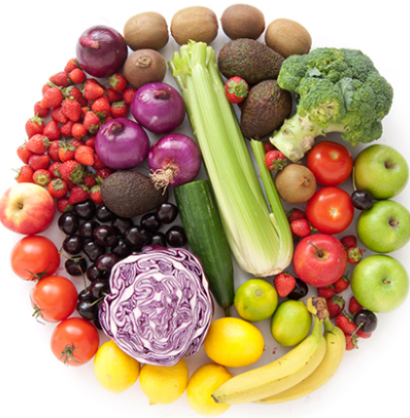
- Which caller thinks that some fruits and vegetables are unhealthy?
  - Kevin
  - Kate
  - Derek
  - Rosie
- Which caller says that most children prefer fast food?
  - Kevin
  - Kate
  - Derek
  - Rosie
- Which caller eats very little fruit?
  - Kevin
  - Kate
  - Derek
  - Rosie
- Which caller is very healthy because he/she eats a lot of fruits and vegetables?
  - Kevin
  - Kate
  - Derek
  - Rosie

