Second conditional
Read Grammar Bank 7B. Then complete the second conditional statements and questions with the correct form of the verbs in parenthesis. Listen and check.
Grammar Bank
7B second conditional, choosing between conditionals
second conditional sentences: if + simple past, would / wouldn’t + base form
EXAMPLES
1 If I had a job, I’d get my own apartment.
If David spoke good English, he could get a job in that new hotel.
I would get along better with my parents if I didn’t live with them.
I wouldn’t do that job unless they paid me a really good salary.
2 If your sister were here, she’d know what to do.
If it was warmer, we could have a swim.
3 If I were you, I’d buy a new computer.
FORM
• We use the second conditional to talk about a hypothetical / imaginary present or future situation and its consequence.
If I had a job… (= I don’t have a job, I’m imagining it)
1 We use the simple past after if and would / wouldn’t + base form in the other clause.
• We can also use could instead of would in the other clause.
2 After if, we can use was or were with I, he, and she.
3 We often use second conditionals beginning If I were you, I’d… to give advice. We don’t normally use If I was you…

1. Nick __________ commute every day if he __________ from home. (not have to, work)
2. If they __________ such a noisy dog, they __________ better with their neighbors. (not have, get along)
3. I __________ that bike if I __________ you. It's too expensive. (not buy, be)
4. Would you __________ your house if somebody __________ you enough money? (sell, offer)
5. If my mother-in-law __________ with us, we __________ divorced. (live, get)
6. __________ you __________ an apartment with me if I __________ half the rent? (share, pay)
7. If my sister __________ her room more often, it __________ such a mess. (clean, not be)
8. You __________ me like this if you really __________ me. (not treat, love)
9. If we __________ the kitchen white, __________ it __________ bigger? (paint, look)
10. I __________ a house with a yard if I __________ yard work so much. (not buy, not enjoy)

Choosing between conditionals
First or second conditional? Complete the sentences with the correct form of the verb in parenthesis. Listen and check.
1. My kids _________ earlier if they didn’t go to bed so late. (get up)
2. Where _________ you _________ if you go to college? (live)
3. If you _________ your exams, what will you do? (not pass)
4. I’d buy a bigger house if I _________ sure we could afford it. (be)
5. We couldn’t have a dog if we _________ a yard. (not have)
6. How will you get to work if you _________ your car? (sell)
7. If we sit in the shade, we _________ sunburned. (not get)
8. If you could change one thing in your life, what _________ it _________ ? (be)
9. He won’t be able to pay next month’s rent if he _________ a job soon. (not find)
10. If she made less noise, her neighbors _________ so often. (not complain)

Houses: Activity 1
Choose the correct preposition, in or on, to complete the sentences. Listen and check.
1. I live in / on the country, surrounded by fields.
2. I live in / on the outskirts of Boston, about 5 miles from the center of the city.
3. I live in / on a village (a town / a city).
4. I live in Del Mar, a small town in / on the West Coast.
5. I live in / on the second floor of a large apartment building.
6. I live in / on Littleton, a suburb of Denver about 11 miles from the center of the city.

Houses: Activity 2
Choose the correct groups of words that match the numbers on the houses. Then listen and check.

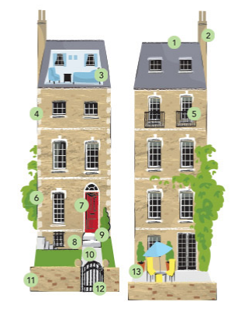
- 1–3:
roof, chimney, attic
- 1–3:
chimney, path, top floor
- 4–6:
patio, attic, balcony
- 4–6:
top floor, balcony, first floor
- 7–9:
wall, balcony, gate
- 7–9:
entrance, basement, steps
- 10–13:
path, wall, gate, patio
- 10–13:
path, wall, basement, steps
Houses: Activity 3
Match the pictures to the descriptions. Listen and check. Focus on how the highlighted phrases are pronounced.
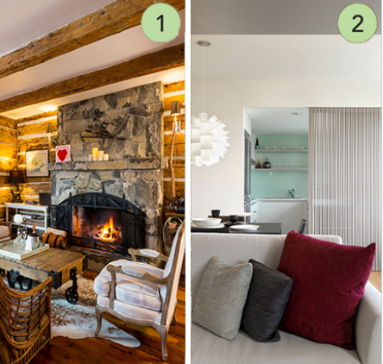
- I live in a cabin in the woods. It’s old and made of logs. The rooms have very low ceilings. There’s a fireplace in the living room and it’s very cozy in the winter.
  - picture 1
  - picture 2
- I live in a modern apartment in the city. It’s spacious and very light, with wood floors and big windows.
  - picture 1
  - picture 2

Sentence stress
Read and listen. Then say and record. Copy the rhythm.
1.If I lived on my own, I’d have to pay rent.
2.Would you leave home if you got a job?
3.Even if I could afford it, I wouldn’t move out.
4.If it were my apartment, I’d be happy to do the cleaning.
5.I’d get along better with my parents if I didn’t live at home.
The letter c
Read and listen to the words in groups 1–5. Then say and record the words.
1.castle carpet location cozy country balcony cook cushion curtains
2.city circle decide center entrance ceiling agency icy
3.spacious special musician
4.occasion accommodations accuse
5.accent success accident

Welcome to Graceland: Activity 1
Listen to a guide giving a tour of Elvis Presley’s home, Graceland. Put places and parts of the house in the order you hear about them.
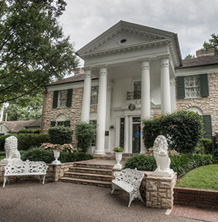
TV room the walls the living room basement
the dining room the front door

1.
2.
3.
4.
5.
6.

Welcome to Graceland: Activity 2
Listen again and complete the sentences. You can read the audio script to help you.
Guide: Ladies and gentlemen, can I have your attention, please? Thank you and welcome to Graceland, the home of music star Elvis Presley. We start our tour here, at the front door of this impressive home. This is the perfect place to look closely at the outside of the house. It was built in the early part of the twentieth century, in a style that was popular at the time. The outside walls of the house are made of stone and wood, and the house has two floors as well as a basement. This house was Elvis’s home from 1957 until 1977 when he died, which means he spent most of his adulthood here. He got married in 1967 and his wife, Priscilla, came to live with him here after they got married. Their only daughter Lisa Marie was born here. So you see, this house played an extremely important role in Elvis’s life. Now, as you’re walking through the house, I’d like you to pay special attention to how different rooms are decorated. One room is decorated to look like a jungle with green rugs, plants of all kinds, and animal-print decorations. Another room, the TV room, was one of the first "home theaters" in the US. Elvis placed three TVs side-by-side on a wall. On Sundays, he could watch three different football games at the same time! OK, if you’ll come this way, we’ll start on the first floor, and the first room we’re going to visit is the dining room. Are you all in? Well, this is the dining room where Elvis enjoyed meals with his guests. The large dining room table could seat about 12 people. The beautiful light hanging over the table is made of Italian glass. Elvis didn’t usually wake up until four in the afternoon, so the dinner parties didn’t start until ten at night! His full-time cooks made old-fashioned Southern food for the dinner parties – and when he wanted a snack, his cooks made him his favorite peanut butter, banana, and bacon sandwiches…which were probably the reason he gained weight as he got older! The dining room was also used by Elvis as a place to play card games with his friends. Now, we’re going to walk across the hall to the living room, and then we’ll head to the music room right behind it. Please follow me. The centerpiece of the living room is a 14-foot-long white leather couch and 10-foot-long coffee table. Quite impressive! The room has a wall covered in mirrors and is decorated in gold, blue, and white. If you look over here, you’ll see a pair of stained-glass birds that lead into the music room. It was in this room that Elvis and his friends spent hours together creating and playing music. When you’re ready, we’ll continue with our tour of the first floor and visit the kitchen and Elvis’s parents’ room, where his father had a swimming pool installed in his bedroom along with a jukebox next to it!
1. The house was built in the early ________ century.
2. Elvis Presley lived in Graceland for ________ years.
3. Elvis got married in ________ .
4. Elvis had ________ child/children.
5. Elvis had ________ TVs in the TV room.
6. Elvis usually woke up at ________ o'clock in the afternoon.
7. Elvis liked to eat, host dinner parties, and play ________ games in the living room.
8. Elvis' parents had a room on the ________ floor.

Writing 6: Describing a house or an apartment
Write a description of a house or apartment.
Friends have asked you for information about a house or apartment where you have stayed on vacation. Write a description for them. Plan what you're going to say using the paragraph notes below and click on Tools for Quick tips.  Paragraph 1 – What kind of house / apartment is it? Where is it exactly?  Paragraph 2 – What rooms does it have? Are there any special features? Is there anything it doesn't have?  Paragraph 3 – Describe the neighborhood. What attractions are nearby? What public transportation is there?  Paragraph 4 – Who is the house / apartment suitable for? Would you recommend it?  Don't forget to check your description for mistakes (grammar, vocabulary, punctuation, and spelling). | Write here...

