Comparatives and superlatives: Activity 1
Read Grammar bank 3A. Then complete the sentences with the comparative or superlative of the bold word (and than if necessary). Listen and check.

Grammar Bank
3A choosing between comparatives and superlatives
comparing two people, places, things, etc.
EXAMPLES
1 My car is a little older than yours.
San Francisco is more expensive than Chicago.
This test is less difficult than the last one.
Olive oil is better for you than butter.
2 The new sofa isn’t as comfortable as the old one.
I don’t have as many books as I used to.
FORM
1 We use comparative adjectives + than to compare two people, places, things, etc.
• Regular comparative adjectives: spelling rules old ➞ older big ➞ bigger easy ➞ easier modern ➞ more modern difficult ➞ more difficult
• Irregular comparative adjectives: good ➞ better bad ➞ worse far ➞ further / farther
• One-syllable adjectives ending in -ed: bored ➞ more bored stressed ➞ more stressed tired ➞ more tired
2 We can also use (not) as + adjective + as to make comparisons.
comparing two actions
EXAMPLES
1 My father drives faster than me.
He walks more slowly than I do.
Atlanta played worse today than last week.
2 Max doesn’t speak English as well as his wife does.
I don’t earn as much as my boss.
FORM
1 We use comparative adverbs to compare two actions.
• Regular comparative adverbs: spelling rules fast ➞ faster slowly ➞ more slowly carefully ➞ more carefully
• Irregular comparatives: well ➞ better badly ➞ worse
2 We can also use (not) as + adverb + as to make comparisons.
superlatives
EXAMPLES
Kevin is the tallest player on the team.
Singapore is the most expensive city in the world.
The small bag is the least expensive.
Lucy is the best student in the class.
Who dresses the most fashionably in your family?
That’s the worst we’ve ever played.
FORM
• We use superlative adjectives and adverbs to compare people, things, or actions with all of their group.
• We form superlatives like comparatives, but we use -est instead of -er and the most / least instead of more / less.
• We normally use the before superlatives, but we can also use possessive adjectives, e.g., my best friend, their most famous song.
• We often use a superlative with the present perfect + ever. It’s the best book I’ve ever read.

1. I think skiing is _________ horseback riding. easy
2. A motorcycle is _________ a scooter. powerful
3. I think that traveling by train is _________ form of transportation. relaxing
4. My grandfather walks _________ I do. slowly
5. _________ time to travel is on holiday weekends. bad
6. _________ I’ve ever driven is from Chicago to Los Angeles. far
7. The subway in Boston is _________ the subway in New York. old
8. This is _________ bus I’ve ever been on. hot
9. Of all my family, my mom is _________ driver. good

Comparatives and superlatives: Activity 2
Complete the sentences with one word. Then listen and check.
1. A bus isn’t as comfortable __________ a train.
2. It’s __________ most expensive car we’ve ever bought.
3. The traffic was worse __________ we expected.
4. This is the longest trip I’ve __________ been on.
5. He gets home late, but his wife arrives later than __________ .
6. The __________ interesting place I’ve ever visited is Tokyo.
7. I leave home at the same time __________ my brother.
8. He drives __________ carefully than his girlfriend – he’s never had an accident.
9. We don’t go abroad __________ often as we used to.
10. What’s the longest highway __________ the US?

Transportation: Activity 1
Choose the correct groups of words that match the numbered photos. Then listen and check.

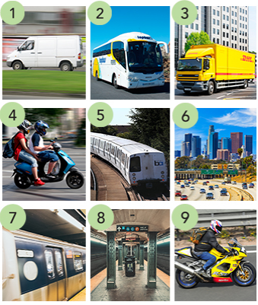

- 1–3:
van, bus, truck
- 1–3:
scooter, ﻿plat﻿form, bus
- 4–6:
motorcycle, truck, the subway,
- 4–6:
scooter, train, freeway
- 7–9:
motorcycle, train, van
- 7–9:
the subway, plat﻿form, motorcycle
Transportation: Activity 2
Look at the pictures and complete the compound nouns. Then listen and check.
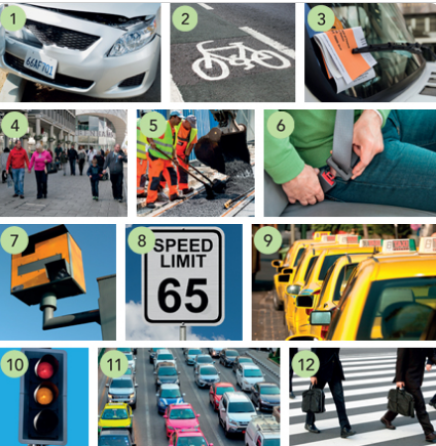

- car ______
  - crash
  - zone
  - ﻿walk
- bi﻿cycle ______
  - limit
  - lights
  - lane
- parking ______
  - belt
  - jam
  - ti﻿cket
- pedestrian
  - lane
  - zone
  - stand
- road ______
  - ﻿ti﻿cket
  - camera
  - work
- seat ______
  - crash
  - work
  - belt
- speed ______
  - camera
  - lights
  - crossing
- speed
  - limit
  - zone
  - lights
- taxi ______
  - limit
  - ﻿ti﻿cket
  - stand
- traffic
  - stand
  - work
  - lights
- traffic ______
  - lane
  - camera
  - jam
- ﻿cross
  - ﻿walk
  - belt
  - crash

Transportation: Activity 3
Complete the phrasal verbs with a verb from the list. Listen and check.
end set Look run pick
1. We _________ off at 7:00 in the morning to try to avoid the traffic.
2. I arrive at 8:15. Do you think you could _________ me up at the train station?
3. Always check the address you put in your GPS or you may _________ up in the wrong place.
4. We’re going to _________ out of gas soon. Let’s stop at the next gas station.
5. _________ out! You’re going to crash!
/ʃ/, /dʒ/, and /tʃ/
Listen and read. Match the letter o words to the correct sound pictures.
- adventure
  - /ʃ/ shower
  - /dʒ/ large
  - /tʃ/ chess

- bridge
  - /ʃ/ shower
  - /dʒ/ large
  - /tʃ/ chess

- catch
  - /ʃ/ shower
  - /dʒ/ large
  - /tʃ/ chess

- coach
  - /ʃ/ shower
  - /dʒ/ large
  - /tʃ/ chess

- crash
  - /ʃ/ shower
  - /dʒ/ large
  - /tʃ/ chess

- journey
  - /ʃ/ shower
  - /dʒ/ large
  - /tʃ/ chess

- rush
  - /ʃ/ shower
  - /dʒ/ large
  - /tʃ/ chess

- station
  - /ʃ/ shower
  - /dʒ/ large
  - /tʃ/ chess

- traffic jam
  - /ʃ/ shower
  - /dʒ/ large
  - /tʃ/ chess

Linking
Listen for the linked words and complete the sentences. Listen again and repeat. Try to link the marked words.

- __________ __a __________ __is __________ __ __________ than driving.
- The __________ ____________ __ __________ __________ __an __________ __and__a __________ .
- It’s more __________ __to __________ __at night than during the day.
- My father’s __________ __at ____________ than my mother.
- The __________ __ __________ __________ __ in my __________ __ is Main Street.

Alternative transportation: Activity 1
Read and listen to the article. Choose the correct answers.
Unusual ways of getting around
Bamboo trains
This is the best way to see rural Cambodia. A bamboo train, or nori as the locals call it, is a bamboo platform on wheels which travels along tracks. It’s powered by an engine, and it can reach a speed of 25 miles per hour. Passengers sit on a grass mat on the nori. Noris may not be as comfortable as conventional trains, but they’re certainly a lot cheaper. Pick up a nori from Battambang Station, but remember to agree on a price before you get on.
Totora reed boats
These boats have been around for centuries. They are made from the reeds that grow on the banks of Lake Titicaca, one of the largest lakes in South America. As well as making boats from totora reeds, the local people use them to make their houses, which they build on floating islands. Totora reed boats are still used for hunting and fishing, but today some of the local people transport people across the lake in them. Traveling on a reed boat among the floating islands of the lake is a must for visitors to Peru.
Jeepney
A jeepney is the most common form of public transport in the Philippines. They are made out of the jeeps left on the islands by the American army at the end of World War II. The people gave the jeeps a roof, put in two long seats on either side and painted them, turning them into small buses. Jeepneys have open windows instead of air conditioning. They’re often packed with passengers and there are no bus stops – the driver just slows down to let the passengers jump on and off.
Dog sleds
Dog sledding is a unique experience as it’s something you can’t do in many parts of the world. It was once the only way to get around in the snow of Alaska, but now its use is limited to winter sports and tourism. The best time to try it is from January to March – in the summer there isn’t enough snow so the dogs pull sleds on wheels. The ride can be a bit bumpy as the sled sometimes goes over stones and the dogs bark a lot. All the same, it’s an opportunity not to be missed.

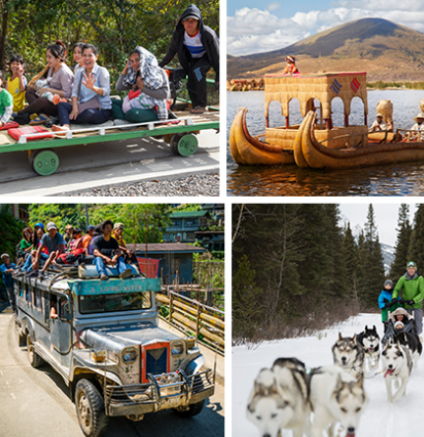
  - Which is the oldest form of transportation?
  - Bamboo trains
  - Totora reed boats
  - Jeepneys
  - Dog sleds
- Which form of transportation is used by the most people?
  - Bamboo trains
  - Totora reed boats
  - Jeepneys
  - Dog sleds
Alternative transportation: Activity 2
Read the article again. Decide if the sentences are True or False. Then look at the underlined words and phrases. What do you think they mean?
Unusual ways of getting around
Bamboo trains
This is the best way to see rural Cambodia. A bamboo train, or nori as the locals call it, is a bamboo platform on wheels which travels along tracks. It’s powered by an engine, and it can reach a speed of 25 miles per hour. Passengers sit on a grass mat on the nori. Noris may not be as comfortable as conventional trains, but they’re certainly a lot cheaper. Pick up a nori from Battambang Station, but remember to agree on a price before you get on.
Totora reed boats
These boats have been around for centuries. They are made from the reeds that grow on the banks of Lake Titicaca, one of the largest lakes in South America. As well as making boats from totora reeds, the local people use them to make their houses, which they build on floating islands. Totora reed boats are still used for hunting and fishing, but today some of the local people transport people across the lake in them. Traveling on a reed boat among the floating islands of the lake is a must for visitors to Peru.
Jeepney
A jeepney is the most common form of public transport in the Philippines. They are made out of the jeeps left on the islands by the American army at the end of World War II. The people gave the jeeps a roof, put in two long seats on either side and painted them, turning them into small buses. Jeepneys have open windows instead of air conditioning. They’re often packed with passengers and there are no bus stops – the driver just slows down to let the passengers jump on and off.
Dog sleds
Dog sledding is a unique experience as it’s something you can’t do in many parts of the world. It was once the only way to get around in the snow of Alaska, but now its use is limited to winter sports and tourism. The best time to try it is from January to March – in the summer there isn’t enough snow so the dogs pull sleds on wheels. The ride can be a bit bumpy as the sled sometimes goes over stones and the dogs bark a lot. All the same, it’s an opportunity not to be missed.
- Noris are a good way of seeing Cambodian cities.
  - True
  - False
- The train fare is not always the same.
  - True
  - False
- Totora reed boats are made from special plants.
  - True
  - False
- Today the boats are only used to carry tourists.
  - True
  - False
- Jeepneys have been used in the Philippines for about twenty years.
  - True
  - False
- There are usually a lot of people in jeepneys.
  - True
  - False
  - Today, fewer people in Alaska use dog sleds than before.
  - True
  - False
    - Dog sleds are a very relaxing way to travel.
  - True
  - False

