**Simple present and continuous**

1.  Come on, let's order. The waiter is coming .

2.  The head chef is sick, so he isn't working today.

3.  I call my sister in New York once a week.

4.  What do you usually do for lunch?

5.  I didn't use to like oily fish, but now I love it.

6.  We live in the same apartment building, but we never see each other.

7.  We don't go to Chinese restaurants very often.

8.  Can she call you back? She's talking to a customer right now.

9.  The bill seems very expensive to me.

10.  Do we need to go shopping today?

**Action and nonaction verbs**

1. have – eat
2. Does – know
3. look – are – thinking
4. ‘s – cooking – smells
5. doesn't want - 's having
6. think - is getting
7. do – have
8. love – tastes
9. Are – taking
10. 're not making - doesn't like

**Food and cooking: Activity 1**

1. 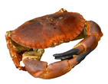
2. 
3. 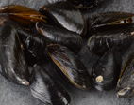
4. 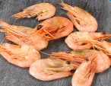
5. 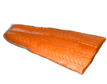
6. 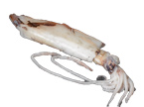
7. 
8. 
9. 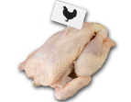
10. 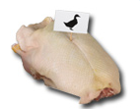
11. 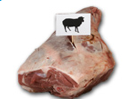
12. 

**Food and cooking: Activity 2**

1. 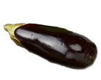
2. 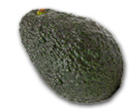
3. 
4. 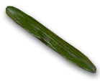
5. 
6. 
7. 
8. 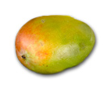
9. 
10. 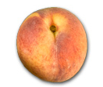
11. 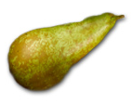
12. 

**Food and cooking: Activity 3**

|  |  |  |  |
| --- | --- | --- | --- |
|  |  |  |  |
|  |  |  |  |
|  |  |  |  |

**Vowel sounds**

|  |  |  |  |
| --- | --- | --- | --- |
| 1. | gr**i**lled squ**i**d | 5. | hot s**au**sages |
| 2. | st**ea**med gr**ee**n b**ea**ns | 6. | f**ou**r f**or**ks |
| 3. | cr**a**b s**a**l**a**d | 7. | a g**oo**d c**oo**k |
| 4. | a l**a**rge c**a**rton of milk | 8. | t**u**na with z**u**cchini |

**The truth about healthy eating: Activity 1**

1. How should I start the day?
2. Do I really need to eat five a day?
3. Can I eat apples?
4. How can I prevent serious illnesses?

**The truth about healthy eating: Activity 2**

1. Rosie
2. Kate
3. Kevin
4. Derek