**Modals of deduction: Activity 1**

1. D
2. I
3. J
4. A
5. C
6. H
7. B
8. F
9. E
10. G

**Modals of deduction: Activity 2**

1. must
2. might not
3. must
4. can't
5. might
6. must
7. might not
8. can't
9. might
10. can't

**The body: Activity 1**

1. 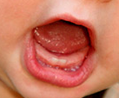
2. 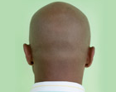
3. 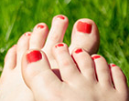
4. 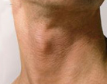
5. 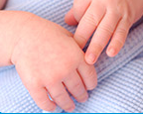
6. 
7. 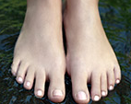
8. 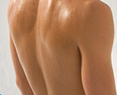
9. 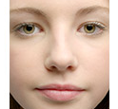
10. 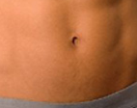
11. 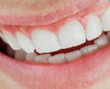

**The body: Activity 2**

1. shoulders
2. eyes
3. fingers
4. tongue
5. ears
6. legs
7. nose
8. knees
9. lips
10. chin
11. thumb

**The body: Activity 3**

1. bite
2. kicked
3. smells
4. stared
5. taste
6. whistle
7. touch
8. clapped
9. pointed
10. smiles
11. nodded

**Diphthongs**

1. bite eyes smile
2. face taste
3. nose shoulders toes throw
4. mouth outgoing
5. pointy voice

**Photoshopping: Activity 1**

1. health organizations
2. Publishers should be able to use it a little.

**Photoshopping: Activity 2**

1. as good as possible
2. All kinds of people
3. it made her look younger than she was
4. consumers