Using adjectives as nouns, adjective order: Activity 1
Read Grammar Bank 2B. Then rewrite the underlined phrase using the + an adjective. Listen and check.
Grammar Bank
2B adjectives as nouns, adjective order
adjectives as nouns
EXAMPLES
1 In most African countries, the young still look up to the old.
The poor are getting poorer, and the rich are getting richer.
The government needs to create more jobs for the unemployed.
2 The English are famous for drinking tea.
The Chinese invented paper.
The Dutch make wonderful cheeses.
FORM
- You can use the + some adjectives to talk about groups of people, e.g.,
1 specific groups in society, such as the young, the old (or the elderly), the sick (= people who are sick), the blind, the deaf, the homeless, the dead.
2 some nationalities that end in -ch, -sh, -ese, and -ss, such as the French, the Spanish, the British, the Japanese, the Irish, the Swiss, etc. (most other nationality words are nouns and are used in the plural, e.g., the Brazilians, the Peruvians, the Turks, the South Koreans, the Argentinians, etc.).
- You can also use adjective + people to talk about a group of people, e.g., poor people, homeless people, old people, Thai people.
- To talk about one person, use, e.g., a Japanese woman, a rich man, etc. NOT a Japanese, a rich.
adjective order
EXAMPLES
We have a charming old house near the lake.
She has long brown hair.
I bought a beautiful Italian leather belt.
FORM
- You can put more than one adjective before a noun (often two and occasionally three). These adjectives go in a particular order, e.g., NOT an old charming house.
- Opinion adjectives, e.g., beautiful, nice, lovely, always go before descriptive adjectives, e.g., big, old, round.
- If there is more than one descriptive adjective, they go in this order: OPINION > SIZE > AGE > SHAPE > COLOR > PATTERN > ORIGIN/PLACE > MATERIAL > NOUN
e.g., expensive, little, brand new, long, purple, striped, French, silk scarf

1. People from Vietnam enjoy spicy food.
____________ enjoy spicy food.
2. People from the Netherlands tend to be good at languages.
____________ tend to be good at languages.
3. Clara Barton took care of people who weren't well during the American Civil War.
Clara Barton took care of ____________ during the American Civil War.
4. The system of reading for people who can't see is called Braille.
The system of reading for ____________ is called Braille.
5. People from China have a fascinating history.
____________ have a fascinating history.
6. Ambulances arrived to take the people who had been injured to the hospital.
Ambulances arrived to take ____________ to the hospital.
7. The worst season for people without a home is winter.
The worst season for ____________ is winter.
8. There is a discount for people without a job.
There is a discount for ____________ .
9. The World War II monument was erected to honor the people who died.
The World War II monument was erected to honor ____________ .
10. There are special TV shows for people who can't hear﻿ that use sign language.
There are special TV shows for ____________ that use sign language.

Using adjectives as nouns, adjective order: Activity 2
Read Grammar Bank 2B. Complete the phrases using the adjectives in parentheses in the correct order. Use a or an where necessary. You do not need to add commas.
Grammar Bank
2B adjectives as nouns, adjective order
adjectives as nouns
EXAMPLES
1 In most African countries, the young still look up to the old.
The poor are getting poorer, and the rich are getting richer.
The government needs to create more jobs for the unemployed.
2 The English are famous for drinking tea.
The Chinese invented paper.
The Dutch make wonderful cheeses.
FORM
- You can use the + some adjectives to talk about groups of people, e.g.,
1 specific groups in society, such as the young, the old (or the elderly), the sick (= people who are sick), the blind, the deaf, the homeless, the dead.
2 some nationalities that end in -ch, -sh, -ese, and -ss, such as the French, the Spanish, the British, the Japanese, the Irish, the Swiss, etc. (most other nationality words are nouns and are used in the plural, e.g., the Brazilians, the Peruvians, the Turks, the South Koreans, the Argentinians, etc.).
- You can also use adjective + people to talk about a group of people, e.g., poor people, homeless people, old people, Thai people.
- To talk about one person, use, e.g., a Japanese woman, a rich man, etc. NOT a Japanese, a rich.
adjective order
EXAMPLES
We have a charming old house near the lake.
She has long brown hair.
I bought a beautiful Italian leather belt.
FORM
- You can put more than one adjective before a noun (often two and occasionally three). These adjectives go in a particular order, e.g., NOT an old charming house.
- Opinion adjectives, e.g., beautiful, nice, lovely, always go before descriptive adjectives, e.g., big, old, round.
- If there is more than one descriptive adjective, they go in this order: OPINION > SIZE > AGE > SHAPE > COLOR > PATTERN > ORIGIN/PLACE > MATERIAL > NOUN
e.g., expensive, little, brand new, long, purple, striped, French, silk scarf

1. (young / attractive): ______________________ man
2. (old / dirty): ______________________ shoes
3. (black / beautiful / velvet): ______________________ jacket
4. (teenage / tall / American): ______________________ girl
5. (sandy / long): ______________________ beach
6. (magnificent / 17th century / country): ______________________ house
7. (Italian / leather / stylish): ______________________ bag
8. (huge / dark): ______________________ eyes
9. (black / friendly / old): ______________________ dog
10. (striped / cotton): ______________________ T-shirt

Clothes and fashion: Activity 1
Listen and read. Match the word to the correct picture.

1. tight
- 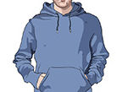
- 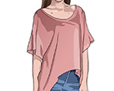
- 
2. loose
- 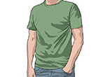
3. sleeveless
- 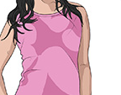
4. long-sleeved
- 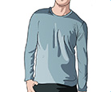
- 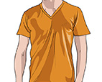
5. V-neck
- 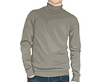
6. hooded
7. turtleneck
8. plain
- 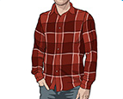
- 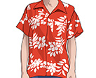
9. striped
- 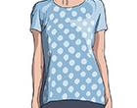
- 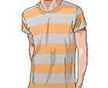
10. patterned
11. dotted
12. plaid

Clothes and fashion: Activity 2
Look at the photos and choose the correct answers.
1. a fur / velvet / cotton undershirt | 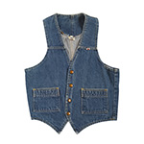
2. a lycra / wool / denim vest | 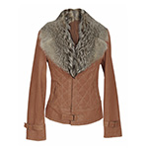
3. a leather / fur / silk collar | 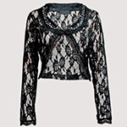
4. a velvet / suede / lace top | 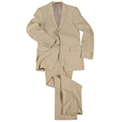
5. a wool / lace / linen suit
6. a lycra / leather / denim swimsuit | 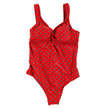
7. a fur / silk / suede scarf | 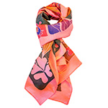
8. lace / cotton /velvet bow tie | 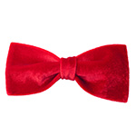
9. a denim / linen / wool cardigan | 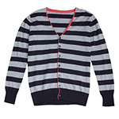
10. leather / lycra / fur sandals | 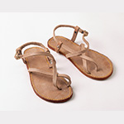
11. suede / lace / silk boots | 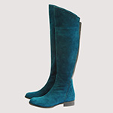

Clothes and fashion: Activity 3
Complete the sentences with an adjective from the box. Then listen and check.
fashionable casual scruffy classic old-fashioned

1. She always wears __________ clothes to work – she hates dressing formally.
2. He looks really __________ . His clothes are old and dirty.
3. Jane looked very __________ in her new suit. She wanted to make a good impression.
4. That tie's a little __________ ! Is it your dad's?
5. I like wearing __________ clothes that don't go out of fashion.

Clothes and fashion: Activity 4
Match the sentences (1-9) to (A-I). Then listen and check.
1. I'm going to dress up tonight. ___
2. Please hang up your coat. ___
3. These jeans don't fit me. ___
4. That skirt really suits you. ___
5. Your bag matches your shoes. ___
6. I need to get changed. ___
7. Hurry up and get undressed. ___
8. Get up and get dressed. ___
9. That tie doesn't really go with your shirt. ___
A Don't leave it on the chair.
B I just spilled coffee on my shirt.
C I'm going to a party.
D They don't look good together.
E It's bath time.
F They're too small.
G They're almost the same color.
H You look great in it.
I Breakfast is on the table.

Vowel sounds
Listen and read. Choose the word with a different sound in each group. Then listen again and repeat.
  - fish /ɪ/
  - denim
  - silk
  - tie

  - tree /i/
  - striped
  - jeans
  - sleeveless

  - egg /ɛ/
  - velvet
  - slippers
  - leather

  - bull /ʊ/
  - shoes
  - wool
  - hooded

  - boot /u/
  - skirt
  - loose
  - suit

Getting older: Activity 1
Listen to a radio program about old age. Check the topics that are discussed.
- being alone
- clothes
- crime
- health
- money
- mood
- resources
- retirement
- sleep
- travel
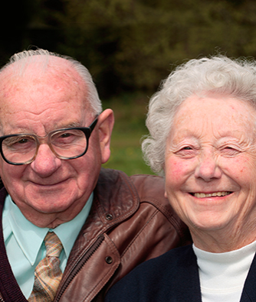

Getting older: Activity 2
Listen again. Choose True or False. You can read the audio script to help you.
  - The elderly tend to be miserable.
  - True
  - False
  - Our future health is programmed entirely by our genes.
  - True
  - False
  - Some people lead busy lives when they reach old age.
  - True
  - False
  - The increase in the number of old people contributes to overpopulation.
  - True
  - False
  - The elderly will be lonely in the future.
  - True
  - False

