Present perfect simple and continuous: Activity 1
Read Grammar Bank 2A. Then choose the correct answers. Listen and check.
Grammar Bank
2A present perfect simple and continuous
present perfect simple: have / has + past participle
EXAMPLES
1 Have you ever broken a bone?
I’ve never seen him before.
2 I’ve called for an ambulance, but it hasn’t arrived yet.
I’ve already told you three times.
3 It’s the best book I’ve ever read.
4 I’ve known Keiko since I was a child.
My sister has been sick for ten days now.
6 How many Patrice Cornwell novels have you read?
They’ve seen each other twice this week.
FORM
- We use the present perfect simple:
1 to talk about past experiences when you don’t say when something happened, often with ever or never.
2 with just, yet, and already.
3 with superlatives and the first, second, last time, etc.
4 with non-action verbs (= verbs not usually used in the continuous form, e.g., be, need, know, like, etc.) to say that something started in the past and is still true now.
- This use is common with time expressions like How long…?, for or since, all day / evening, etc.
- Don’t use the simple present in this situation. NOT I know Keiko since I was a child.
5 when we say or ask how much / many we have done or how often we have done something up to now.
present perfect continuous: have / has + been + verb + -ing
EXAMPLES
1 How long have you been waiting to see the doctor?
He’s been messaging his girlfriend all evening.
2 I haven’t been sleeping well recently. It’s been raining all day.
3 I’ve been shopping all morning. I’m exhausted.
My shoes are filthy. I’ve been working in the yard.
FORM
- We use the present perfect continuous:
1 with action verbs (e.g., run, listen, study, cook) to say that an action started in the past and is still happening now (unfinished actions).
- This use is common with time expressions like How long…?, for or since, all day / evening, etc.
- Don’t use the present continuous in this situation. NOT I’m living here for the last three years.
2 for repeated actions, especially with a time expression, e.g., all day, recently.
3 for continuous actions which have just finished (but which have present results).
present perfect simple or continuous?
EXAMPLES
1 I’ve been feeling terrible for days.
He’s liked classical music since he was a teenager.
2 She’s been having a good time at school.
They’ve had that car for at least ten years.
3 We’ve lived in this town since 2010.
We’ve been living in a rented house for the last two months.
4 I’ve painted the kitchen. I’ve been painting the kitchen.
FORM
1 To talk about an unfinished action, we normally use the present perfect continuous with action verbs (e.g., run, listen, study, cook) and the present perfect simple with non-action verbs (e.g., be, need, know, like, etc.).
2 Some verbs can be action or non-action, depending on their meaning, e.g., have piano lessons = action, have a car = non-action.
3 With the verbs live or work, you can often use the present perfect simple or continuous. However, we normally use the present perfect continuous for more temporary actions.
4 The present perfect simple emphasizes the completion of an action (= the kitchen has been painted). The present perfect continuous emphasizes the duration of an action (= the painting of the kitchen may not be finished yet).

1. Have you ever tried OR been trying / been trying / tried caviar?
2. She's worked OR been working / been working / worked here since July.
3. Your mother has called / been calling / called OR been calling three times this morning!
4. The kids are exhausted because they've been running / run / run OR been running around all day.
5. Tim and Lucy haven't seen / been seeing / seen OR been seeing our new house yet.
6. I've never met / been meeting / met OR been meeting her boyfriend. Have you?
7. It's snowed OR been snowing / snowed / been snowing all morning.
8. My brother has been living / lived OR been living / lived alone since his divorce.
9. I've read OR been reading / read / been reading all morning. I'm on page 120 of my book.

Present perfect simple and continuous: Activity 2
Read Grammar Bank 2A. Then complete the sentences with the present perfect simple or continuous form of the verb in parentheses. Use contractions. Listen and check.
Grammar Bank
2A present perfect simple and continuous
present perfect simple: have / has + past participle
EXAMPLES
1 Have you ever broken a bone?
I’ve never seen him before.
2 I’ve called for an ambulance, but it hasn’t arrived yet.
I’ve already told you three times.
3 It’s the best book I’ve ever read.
4 I’ve known Keiko since I was a child.
My sister has been sick for ten days now.
6 How many Patrice Cornwell novels have you read?
They’ve seen each other twice this week.
FORM
- We use the present perfect simple:
1 to talk about past experiences when you don’t say when something happened, often with ever or never.
2 with just, yet, and already.
3 with superlatives and the first, second, last time, etc.
4 with non-action verbs (= verbs not usually used in the continuous form, e.g., be, need, know, like, etc.) to say that something started in the past and is still true now.
- This use is common with time expressions like How long…?, for or since, all day / evening, etc.
- Don’t use the simple present in this situation. NOT I know Keiko since I was a child.
5 when we say or ask how much / many we have done or how often we have done something up to now.
present perfect continuous: have / has + been + verb + -ing
EXAMPLES
1 How long have you been waiting to see the doctor?
He’s been messaging his girlfriend all evening.
2 I haven’t been sleeping well recently. It’s been raining all day.
3 I’ve been shopping all morning. I’m exhausted.
My shoes are filthy. I’ve been working in the yard.
FORM
- We use the present perfect continuous:
1 with action verbs (e.g., run, listen, study, cook) to say that an action started in the past and is still happening now (unfinished actions).
- This use is common with time expressions like How long…?, for or since, all day / evening, etc.
- Don’t use the present continuous in this situation. NOT I’m living here for the last three years.
2 for repeated actions, especially with a time expression, e.g., all day, recently.
3 for continuous actions which have just finished (but which have present results).
present perfect simple or continuous?
EXAMPLES
1 I’ve been feeling terrible for days.
He’s liked classical music since he was a teenager.
2 She’s been having a good time at school.
They’ve had that car for at least ten years.
3 We’ve lived in this town since 2010.
We’ve been living in a rented house for the last two months.
4 I’ve painted the kitchen. I’ve been painting the kitchen.
FORM
1 To talk about an unfinished action, we normally use the present perfect continuous with action verbs (e.g., run, listen, study, cook) and the present perfect simple with non-action verbs (e.g., be, need, know, like, etc.).
2 Some verbs can be action or non-action, depending on their meaning, e.g., have piano lessons = action, have a car = non-action.
3 With the verbs live or work, you can often use the present perfect simple or continuous. However, we normally use the present perfect continuous for more temporary actions.
4 The present perfect simple emphasizes the completion of an action (= the kitchen has been painted). The present perfect continuous emphasizes the duration of an action (= the painting of the kitchen may not be finished yet).

1. I __________________ you a new car. Do you like it? (buy)
2. You look really sweaty. __________________ at the gym? (you / work out)
3. Emily __________________ her homework yet, so I'm afraid she can't go out. (not do)
4. They don't live in Toronto any more – they __________________ . (move)
5. I hope they're getting along OK. They __________________ a lot recently. (argue)
6. We __________________ for hours. Are you sure we're going the right way? (walk)
7. Why is my laptop on? __________________ it? (you / use)
8. Oh no! I __________________ my finger on this knife. (cut)

Illnesses and injuries: Activity 1
Read the article. Then match the underlined words in the article with the definitions.

1.a cough
- 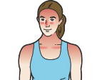
- 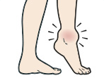
- 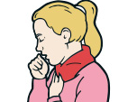
2.a headache
- 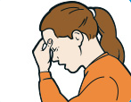
- 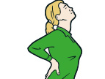
- 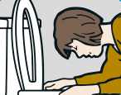
3.a rash
- 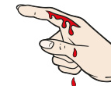
- 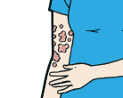
- 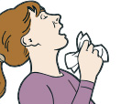
4.a temperature
- 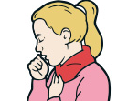
- 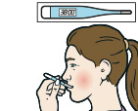
- 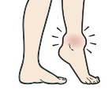
5.sunburn
- 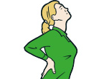
- 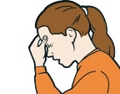
- 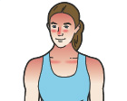
6.She's sick. / She's vomiting.
- 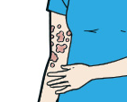
- 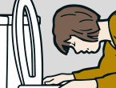
- 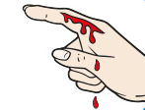
7.She's sneezing.
- 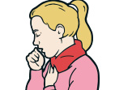
- 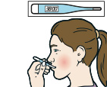
- 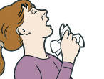
8.Her ankle is swollen.
- 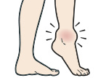
- 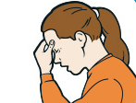
- 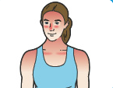
9.Her back hurts. / Her back aches.
- 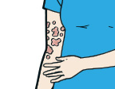
- 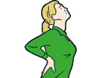
- 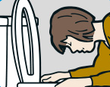
10. Her finger is bleeding.
- 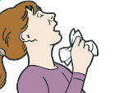
- 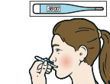
- 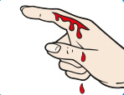

Illnesses and injuries: Activity 2
Match the illnesses and conditions with their cause or symptoms. Then listen and check.
1. ___ He has a sore throat.
2. ___ He has diarrhea.
3. ___ He feels sick.
4. ___ He's fainted.
5. ___ He has a blister on his foot.
6. ___ He has a cold.
7. ___ He has the flu.
8. ___ He feels dizzy.
9. ___ He's cut himself.
A He has a temperature and he aches all over.
B It hurts when he talks or swallows food.
C It's so hot in the room that he's lost consciousness.
D He's been to the bathroom five times this morning.
E He feels like he's going to vomit.
F He's sneezing a lot and he has a cough.
G He feels like everything is spinning around.
H He's been walking in uncomfortable shoes.
I He's bleeding.

Illnesses and injuries: Activity 3
Read the injuries and conditions in the box. Then listen and match them with what you hear.
He has high blood pressure. He's sprained his ankle.
He's had an allergic reaction. He's choking.
He's unconscious. He's burned his hand.
He has food poisoning.

Illnesses and injuries: Activity 4
Match the bold phrasal verbs to their meanings.
vomit, be sick put your body in a horizontal position faint
become conscious again get better / recover from something

1. Please lie down on the couch. I'm going to examine you.
2. After two hours waiting in the sun, I passed out...
3. ...and when I came around, I was lying on the floor.
4. It often takes a long time to get over the flu.
5. After drinking the liquid, I had to run to the bathroom to throw up.

/ʃ/, /dʒ/, /tʃ/, and /k/
Listen and write the words you hear. Then listen and repeat.
1. shower /ʃ/: _________ _________ _________ _________
2. jazz /dʒ/: _________ _________ _________ _________
3. chess /tʃ/: _________ _________
4. key /k/: _________ _________ _________

Medical myths: Activity 1
Read the article, then choose the correct missing sentences.
Medical myths
Good doctors are always learning new things, but very few of them question existing medical myths. A well-known medical journal recently examined the most common of these to see if there is any evidence that they are true. This is what they discovered..
Myth: We only use about 10% of our brains
This myth appeared in the early twentieth century, when the concept of self-improvement was born. The idea was that there are many abilities built into our brains, but if we do not develop them, we never learn how to do them. This led to the belief that there are parts of our brains that we do not use. However, scientific evidence shows that this is not the case. Brain scans have revealed that there is no area of the brain that is silent or inactive. 1 _____ Nobody who has examined the brain has been able to identify the 90% that we, supposedly, do not use.
Myth: Shaving hair causes it to grow back thicker
This belief is often reinforced by the media, despite the fact that a clinical trial in 1928 showed that shaving has no effect on hair growth. 2 _____ This makes it unlikely for the hair to grow back any different than it was before. The reason it appears thicker is that recently shaved hair lacks the finer point seen at the ends of unshaven hair. In addition to this, the new hair has not been lightened by the sun, which makes it look darker than the hair that has already grown.
Myth: Reading in insufficient light ruins your eyesight
People tend to believe this because of the discomfort they experience when they have been reading for a while in dim light. 3 _____ This causes our eyes to dry out and feel uncomfortable. Fortunately, the effect is only temporary and most ophthalmologists—doctors who specialize in eyes—agree that it doesn’t damage our eyes permanently. Something else that disproves the myth is that there are more short-sighted people today than in the past, when reading conditions were worse. Before the invention of electricity, people relied on candles or lanterns to read, yet fewer people needed glasses.
Myth: Eating turkey makes people feel especially tired
Some foods contain a natural chemical called tryptophan, which is known to cause drowsiness. The myth is the idea that consuming turkey (and the tryptophan it contains) might make someone more likely to fall asleep. Actually, both chicken and ground beef have nearly the same amount of tryptophan as turkey; other foods, such as pork or cheese, contain even more. The truth is that any large, solid meal can make you feel sleepy, whether it contains turkey or not. 4 _____ It isn’t the turkey in your dinner that puts you to sleep; it is the quantity of food that you have eaten.
1.
  - Making an effort to focus on the page means that we blink less often.
  - Each of its functions happens in a particular area, and different regions are used for different tasks.
  - This is because the flow of blood to the brain decreases while the body digests it.
  - When the dead part above the surface of the skin is removed the living section underneath is not affected.
2.
  - Making an effort to focus on the page means that we blink less often.
  - Each of its functions happens in a particular area, and different regions are used for different tasks.
  - This is because the flow of blood to the brain decreases while the body digests it.
  - When the dead part above the surface of the skin is removed the living section underneath is not affected.
3.
  - Making an effort to focus on the page means that we blink less often.
  - Each of its functions happens in a particular area, and different regions are used for different tasks.
  - This is because the flow of blood to the brain decreases while the body digests it.
  - When the dead part above the surface of the skin is removed the living section underneath is not affected.
4.
  - Making an effort to focus on the page means that we blink less often.
  - Each of its functions happens in a particular area, and different regions are used for different tasks.
  - This is because the flow of blood to the brain decreases while the body digests it.
  - When the dead part above the surface of the skin is removed the living section underneath is not affected.

Medical myths: Activity 2
Read the article again. Choose True or False.
Medical myths
Good doctors are always learning new things, but very few of them question existing medical myths. A well-known medical journal recently examined the most common of these to see if there is any evidence that they are true. This is what they discovered..
Myth: We only use about 10% of our brains
This myth appeared in the early twentieth century, when the concept of self-improvement was born. The idea was that there are many abilities built into our brains, but if we do not develop them, we never learn how to do them. This led to the belief that there are parts of our brains that we do not use. However, scientific evidence shows that this is not the case. Brain scans have revealed that there is no area of the brain that is silent or inactive. Each of its functions happens in a particular area, and different regions are used for different tasks. Nobody who has examined the brain has been able to identify the 90% that we, supposedly, do not use.
Myth: Shaving hair causes it to grow back thicker
This belief is often reinforced by the media, despite the fact that a clinical trial in 1928 showed that shaving has no effect on hair growth. When the dead part above the surface of the skin is removed the living section underneath is not affected. This makes it unlikely for the hair to grow back any different than it was before. The reason it appears thicker is that recently shaved hair lacks the finer point seen at the ends of unshaven hair. In addition to this, the new hair has not been lightened by the sun, which makes it look darker than the hair that has already grown.
Myth: Reading in insufficient light ruins your eyesight
People tend to believe this because of the discomfort they experience when they have been reading for a while in dim light. Making an effort to focus on the page means that we blink less often.This causes our eyes to dry out and feel uncomfortable. Fortunately, the effect is only temporary and most ophthalmologists—doctors who specialize in eyes—agree that it doesn’t damage our eyes permanently. Something else that disproves the myth is that there are more short-sighted people today than in the past, when reading conditions were worse. Before the invention of electricity, people relied on candles or lanterns to read, yet fewer people needed glasses.
Myth: Eating turkey makes people feel especially tired
Some foods contain a natural chemical called tryptophan, which is known to cause drowsiness. The myth is the idea that consuming turkey (and the tryptophan it contains) might make someone more likely to fall asleep. Actually, both chicken and ground beef have nearly the same amount of tryptophan as turkey; other foods, such as pork or cheese, contain even more. The truth is that any large, solid meal can make you feel sleepy, whether it contains turkey or not. This is because the flow of blood to the brain decreases while the body digests it. It isn’t the turkey in your dinner that puts you to sleep; it is the quantity of food that you have eaten.

  - Doctors spend a lot of time investigating myths.
  - True
  - False
  - At the beginning of the 1900s, people believed that we only used a small part of our brains.
  - True
  - False
  - Unshaven hair is exactly the same color as hair under the surface of the skin.
  - True
  - False
  - In the past, people's eyesight was worse because they read by candlelight.
  - True
  - False
  - Turkey contains less tryptophan than cheese.
  - True
  - False

