**Present perfect simple and continuous: Activity 1**

1.  Have you ever tried caviar?

2.  She's worked OR been working here since July.

3.  Your mother has called three times this morning!

4.  The kids are exhausted because they've been running around all day.

5.  Tim and Lucy haven't seen our new house yet.

6.  I've never met her boyfriend. Have you?

7.  It's been snowing all morning.

8.  My brother has lived OR been living alone since his divorce.

9.  I've been reading all morning. I'm on page 120 of my book.

**Present perfect simple and continuous: Activity 2**

1. 've bought
2. Have you been working out
3. hasn't done
4. 've moved
5. 've been arguing
6. 've been walking
7. Have you been using
8. 've cut

**Illnesses and injuries: Activity 1**

1. 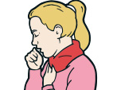
2. 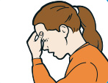
3. 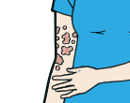
4. 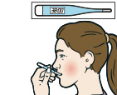
5. 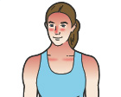
6. 
7. 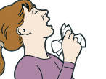
8. 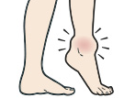
9. 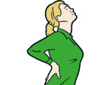

**Illnesses and injuries: Activity 2**

1. B
2. D
3. E
4. C
5. H
6. F
7. A
8. G
9. I

**Illnesses and injuries: Activity 3**

|  |  |
| --- | --- |
|  | He's **unconscious**. |
|  | He's had an **allergic reaction**. |
|  | He's **sprained** his ankle. |
|  | He has **high blood pressure**. |
|  | He has **food poisoning**. |
|  | He's **cho**king. |
|  | He's **burned** his hand. |

**Illnesses and injuries: Activity 4**

1. put your body in a horizontal position
2. faint
3. become conscious again
4. get better / recover from something
5. vomit, be sick

**/ʃ/, /dʒ/, /tʃ/, and /k/**

1. **sh**ower /ʃ/: infection pressure rash unconscious
2. **j**azz  /dʒ/: allergic bandage emergency injury
3. **ch**ess  /tʃ/: choking temperature
4. **k**ey  /k/:   ache sick stomach

**Medical myths: Activity 1**

1. Each of its functions happens in a particular area, and different regions are used for different tasks.
2. When the dead part above the surface of the skin is removed the living section underneath is not affected.
3. Making an effort to focus on the page means that we blink less often.
4. This is because the flow of blood to the brain decreases while the body digests it.

**Medical myths: Activity 2**

1. False
2. True
3. False
4. False
5. True