**Using adjectives as nouns, adjective order: Activity 1**

1. The Vietnamese
2. The Dutch
3. the sick
4. the blind
5. The Chinese
6. the injured
7. the homeless
8. the unemployed
9. the dead
10. the deaf

**Using adjectives as nouns, adjective order: Activity 2**

1. an attractive young
2. dirty old
3. a beautiful black velvet
4. a tall teenage American
5. a long sandy
6. a magnificent 17th century country
7. a stylish Italian leather
8. huge dark
9. a friendly old black
10. a striped cotton

**Clothes and fashion: Activity 1**

1. 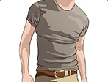
2. 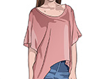
3. 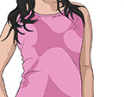
4. 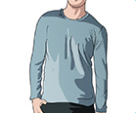
5. 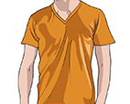
6. 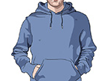
7. 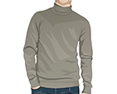
8. 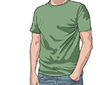
9. 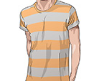
10. 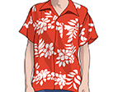
11. 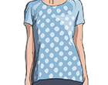
12. 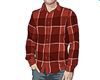

**Clothes and fashion: Activity 2**

1. a cotton undershirt

 2. a denim vest

 3. a fur collar

 4. a lace top

 5. a linen suit

 6. a lycra swimsuit

 7. a silk scarf

 8. a velvet bow tie

 9. a wool cardigan

 10. leather sandals

 11. suede boots

**Clothes and fashion: Activity 3**

1. casual
2. scruffy
3. fashionable
4. old-fashioned
5. classic

**Clothes and fashion: Activity 4**

1. C
2. A
3. F
4. H
5. G
6. B
7. E
8. I
9. D

**Vowel sounds**

1. t**ie**
2. str**i**ped
3. sl**i**ppers
4. sh**o**es
5. sk**i**rt

**Getting older: Activity 1**

* being alone
* health
* mood
* resources
* retirement

**Getting older: Activity 2**

1. False
2. False
3. True
4. False
5. False